Comparison of variable Cryptocurrency assets
DSIM – 604
DR. A
Quinton Carter
Graduate Student

Intro to project
This investigative analysis will be in relation to Cryptocurrencies, trends, and market patterns. Cryptocurrency has been around for over a decade now and has had exponential growth compared to other standard market commodities. To understand cryptocurrency let’s refer to other digital means of currency currently used by banks. A customer gives physical legal tender to a banking institution or transfers digital assets which are interpreted as legal tender to the bank. The bank will then “hold” the customer’s money and give them a plastic card that they are allowed to swipe or tap to send their digital tender to another account. Put in this narrative, it seems like we have been using digital currency for years, but there are additional benefits that cryptocurrency offers that a bank cannot. If someone needs to send money to someone across the world immediately, a bank would not be able to do this. A bank would need several days for processing and several fees for different exchange rate-based items. Crypto exchanges and currencies can be sent and received in seconds as they are based on the equal value of the assets. If a digital asset is worth 5 dollars USD, that asset has the exact same value all over the world. Transaction logs, every single piece of cryptocurrency transactions is publicly available online for anyone to review and monitor. For a bank, when they “hold” your digital currency, the bank is spending it on loans to other customers or on investments and doesn’t publicly allow tracking of that information. A very attractive feature of cryptocurrency is its wide assortment of different offerings each tied to individual utilities. The factor that scares people the most about cryptocurrencies is its volatility, which could be the most attractive feature and biggest downside.
To understand cryptocurrencies growth and popularity further, let’s consider Bitcoin. Bitcoin is the first widely adopted digital currency. Its inception was in 2009, with an opening price of $0. Fast forward to today and Bitcoin’s price is hovering around $40,000. Within its first year, the price of this asset jumped from $0 to $0.09 which is a gain of nearly 9000%. Bitcoin tends to make big leaps, in *“April 13, 2011, from $1 to a peak of $29.60 by June 7, 2011, a gain of 2,960% within three months.” In the past decade, the price of Bitcoin has gone from $5 to currently sitting around $40,000, which is equivalent to $333 each month, $11 each day or almost 1 penny an hour for just holding the asset.
This analysis is going to focus on more than just Bitcoin, although it is the main digital asset on the market. This is going to be a crypto-comparison of different assets, how well they have done in the market within the past year, and how their future projections look. Cryptocurrency is here to stay as a fully integrated part of our environment. Within this analysis, I will be comparing several variations of cryptocurrencies, each asset boasts utilities which the others don’t have. Bitcoin or BTC per this paper will be the gold standard, and literally referred to as digital gold. We are using this as the standard because it is the oldest, widely known, adopted and currently most successful cryptocurrency. We will be pitting BTC against a younger, leaner version of cryptocurrency and its rivel, Ethereum or ETH. This asset boasts it is the next generation of block chain with lower transaction costs, lower fees, less environmental impact and is as widely known as BTC. Finally, Mana or more notably, Decentraland. Decentraland is a fully digital metaverse, the most successful and widely known. They sell land parcels as Non-Fungible Tokens to give the owner access to the land parcel in the Decentraland metaverse.
This analysis will not focus strictly on the price of these assets, since there is a great difference between the 3 (BTC – 40k, ETH – 3k, MANA - $3). The analysis will focus on buying habits and trends between the different currencies. It is widely known that BTC rules the market, if it rises assets in the market run, if it falls assets in the market fall, so we will explore that theory further. I will also explore the growth percentage per individual asset and their projected potential. Each asset is based on different variables that could make them superior to the others, so let’s explore the fundamentals and see what interesting discoveries we can find.

Questions and Charts
Chart A – Review
- Are there any outliers in the data?
  - Yes, there is 11/7 the data shows BTC and all other currencies had a high price of $134k
Let’s explore the average cost data of these 3 currencies to ensure the data credibility. Within the data, there appears to have been an inconsistency with asset prices on November 7th, 2021. With no exterior factors and no other exchanges reporting the same value, on this day can be excluded from the metrics as a clerical error, or corrupted data. Aside from that spike, most of the pricing data seems consistent with the rest of the market.

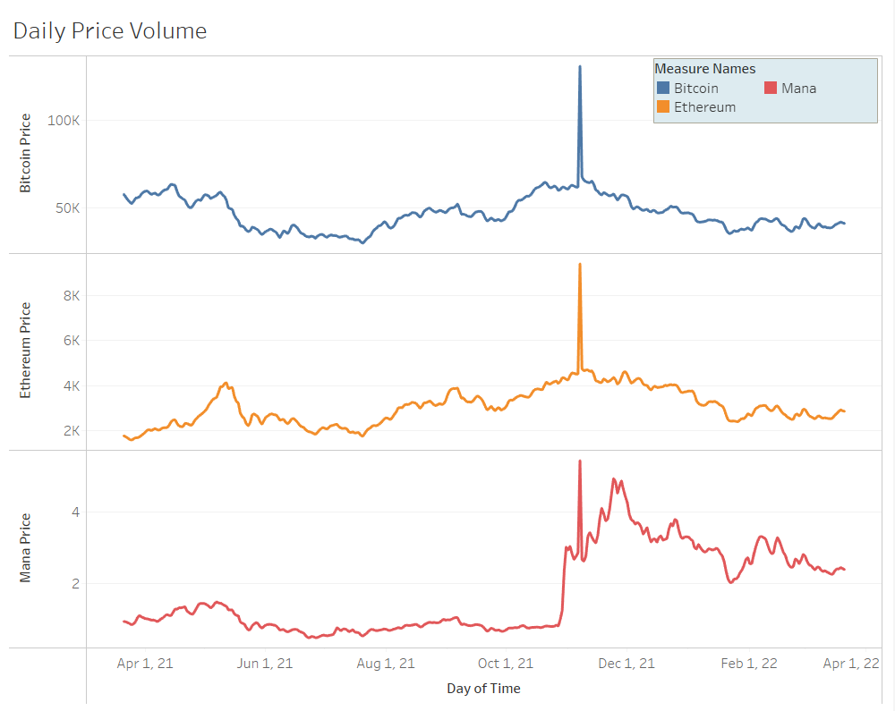
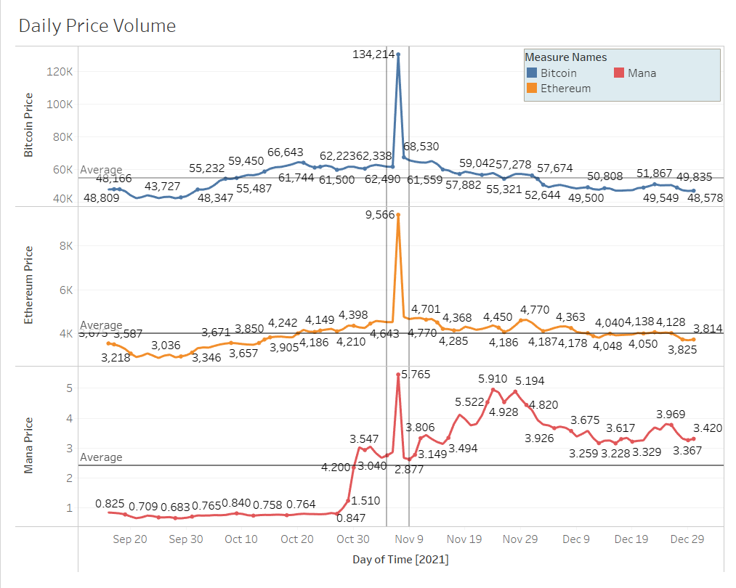

Chart B – Price trends Average/Action
- How does a crypto spike look in reference to averages and volume?
  - The concentration of the volume 10 million transactions is focused on the days leading up to and away from the spike. As the daily range does a violent spike up and back down.
What is a spike in price? The spike terminology is in reference to when there is a sudden increase in price action. As you can see on this chart, this occurred around the beginning of November. The width of the lines is the volume of trading during that time. Meaning, when there is a spike, the volume of trading increases. The concentration of the volume of 10 million transactions is focused on the days leading up to and away from the spike.
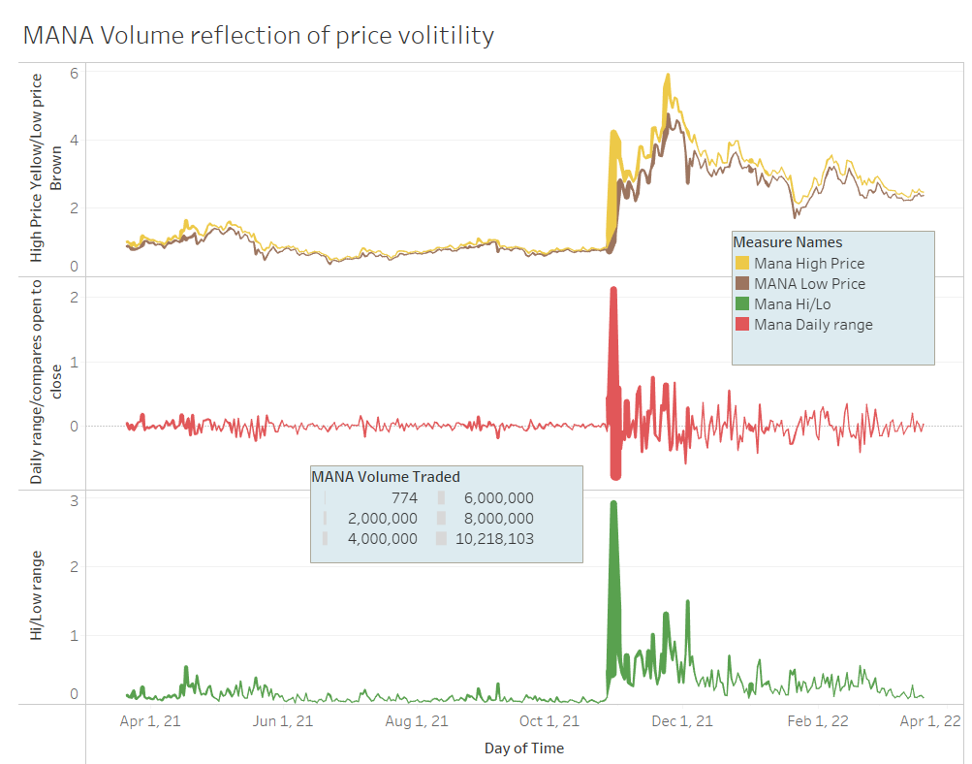
- Which asset has seen the greatest growth per price action in the past year?
  - MANA
- Were there any days specifically that showed spikes in the market?
  - For ETH May 2021 had a rather large spike
  - For MANA the beginning of NOV had a substantial spike
- Did any assets have a major event that sent their price up?
  - MANA from 10/27- 11/7 the price went shot up from .806 to 5.46
After excluding the November date, we see a much more balanced data set. Among the 3 coins, MANA had the greatest growth in price over the past year. This was due to a substantial spike at the beginning of November when the price increased from 0.80 cents to $5.46. This shows that some significant events occurred around that date, which could have been tied to companies buying their land parcels, wider adoption of the NFT marketplace or, in general, wider adoption of the coin.
ETH also had a rather large spike around May 2021 that was corrected by the market quickly. This is seen quite often and could be contributed to price manipulation by large volume traders, or more likely bad news. ETH was lagging behind BTC and was able to catch up only to then follow the volatile path of Bitcoin for the remainder of the year. Based on external factors, I believe this volatility was in relation to the GameStop saga and MEME stock action on the NYSE. Since both MEME stocks and Cryptocurrency are highly volatile risk-based assets, the population that would trade them would be relatively the same. And that is seen through external charts where the price actions are inverted.

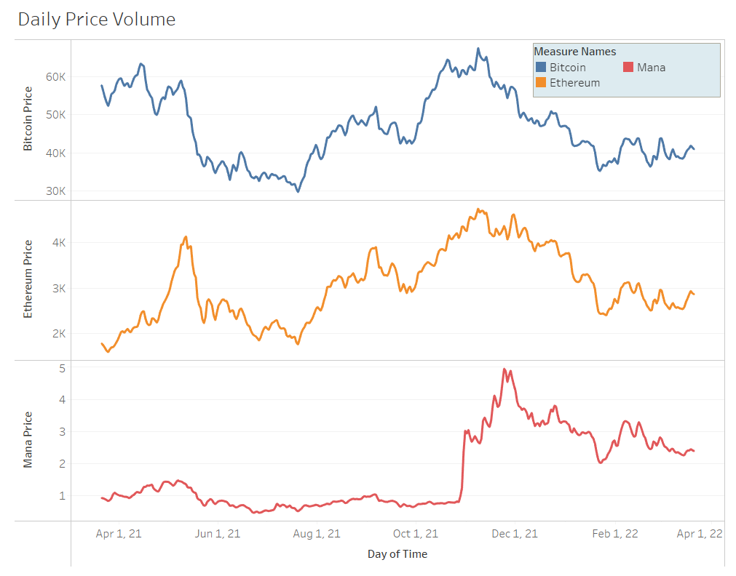
- If you invested in each what would reap higher gains?
For speculative purposes let's assume we timed the market just right and bought in at a point within the past year. If $1000 was invested in each on July 20th 2021, how much would that investment be worth the following year? Each of these assets no matter the level of volatility outperformed storing capital in a banking institution. That is where the draw lies with these assets, although they are high risk the reward is there. MANA increased the initial investment several fold, and ETH improved on its initial investment by 50%.

Asset | Cost on April 1st | Amt to spend | Amt of coins | Cost 1 year later | Investment Value 1 year later | Increase in value
BTC | $29730 | $1,000 | ~0.0336 | $40,970 | $1,376.592 | $376.59
ETH | $1765 | $1,000 | ~0.5665 | $2,872 | $1,626.988 | $626.99
MANA | $0.522 | $1,000 | ~1915.7088 | $2.394 | $4,586.2069 | $3,586.21
USD (in the Bank) | $1 | $1,000 | 1,000 | $1 | $1,001 | $1

- Trend line comparisons for the individual coins?
Below this chart shows 2 types of trend lines in relation to the Average price per day for each day of a month. This is to see if & how a coins price action relates to the Day of the month. I also added a volume metric in there to show any additional features. Due to its massive spike MANA is having an exponentially heavier weight in the lower portion of its price action. BTC and ETH seem standard through the months. There are some interesting wave patterns seen in both these charts between day 10 and 25. These are more prominent in the ETH graphic, and with a more substantial data set could be worth exploring further. The ETH and BTC charts also show a contained cycle. This is where the beginning and end of the trend lines would match, which shows very balanced distribution between each months high and low points in price action.
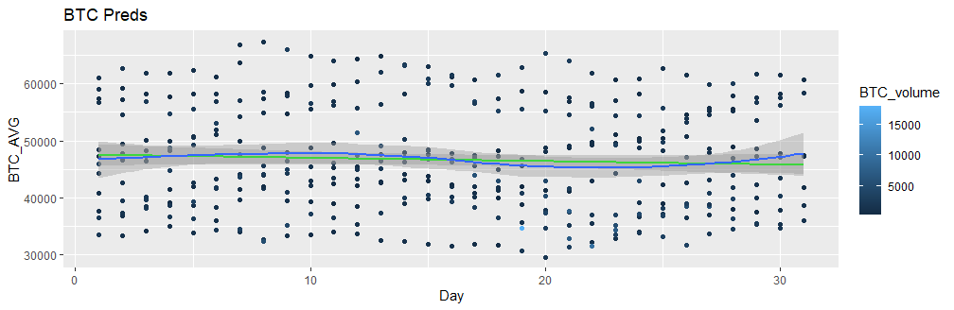
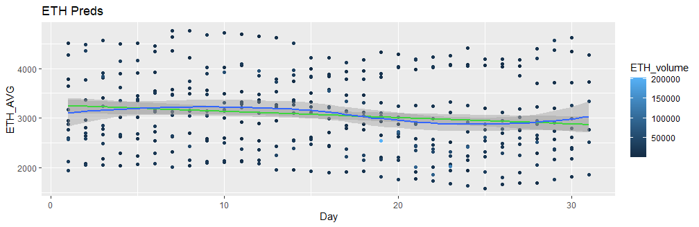
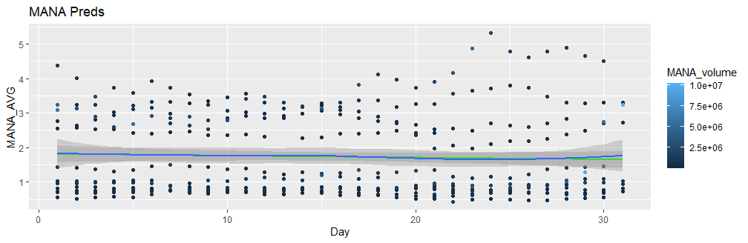

- What is the overall distribution of price action for these over the past year?
  - The data below shows that although there are peaks and valleys between all the coins a more stable value would be one that has even distribution through out its price value range. This means MANA is a real risk bet because the primary accumulation of its value in the past year is lower than the median, where as BTC and ETH are well distributed.
These visuals show how stable the price of the coins is throughout the year. There are going to be peaks & valleys within the price of a high-risk asset, but an asset with an even distribution of value throughout the year can be interpreted as being more stable and a safer bet. Between ETH and BTC, the appearance of an evenly weighted price action is in place which helps us to identify a mean price range or the sweet spot, (click) which is sitting about here. Clustered distribution helps to identify grouping and a viable meaning on the data. The better the cluster in the distribution, the more stable the asset is.
Mana’s charts tell a significantly different story. A mean can be determined but the distribution is too scattered for it to be identified as a stable asset. This means that because of the spike it had in November, MANA is still a real high-risk bet.
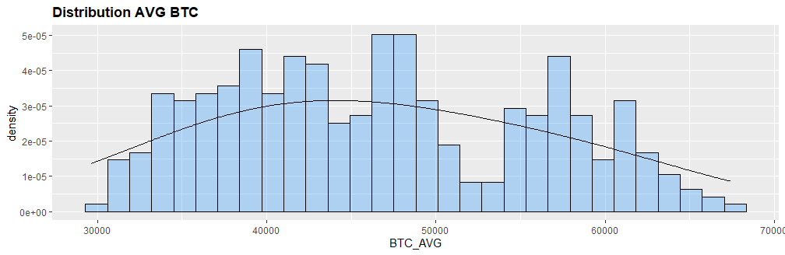
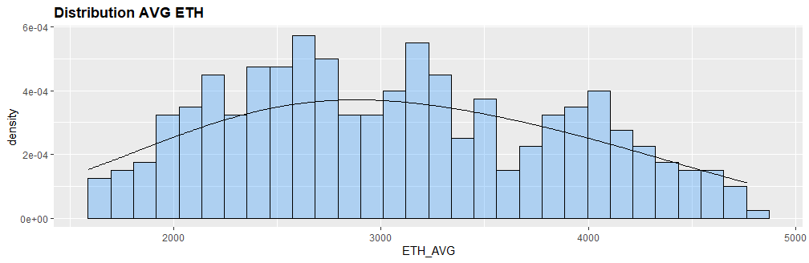
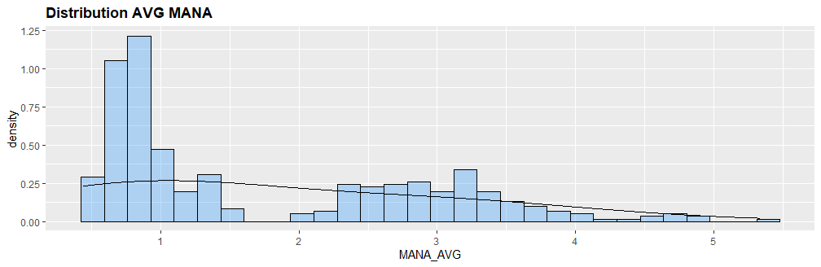

- It is a common fact that BTC is the overall market trend leader. If BTC goes up, the market goes up. Is that the case with all these coins?
  - From this correlation plot, BTC has some significance to ETH and its price action. BTC does not have very much correlation to MANA’s price action. This could be attributed to the spike, but I think not. If you look at MANA to ETH, their correlative pattern was still significant.
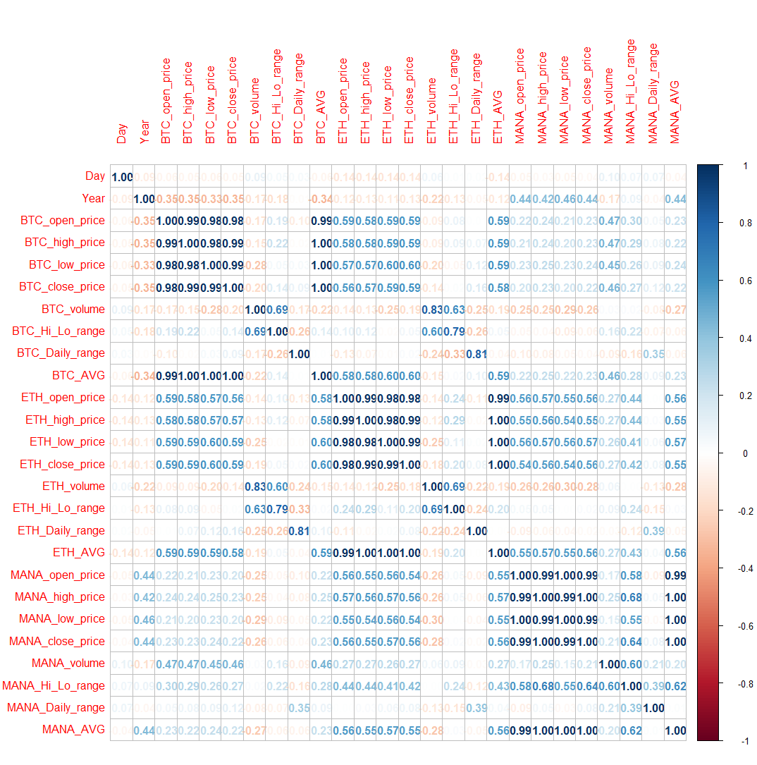
- Other interesting correlations in relation to Coin & Coin
  - ETH has a positive day price action more often between BTC’s higher price actions.
  - When Eth goes up, MANA goes down
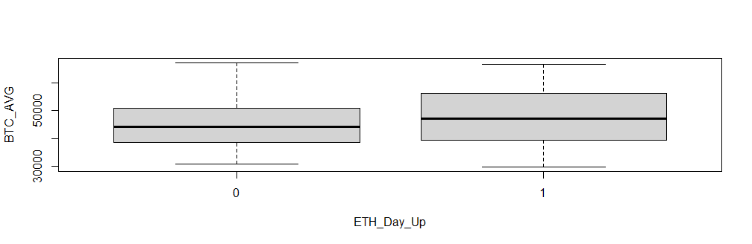
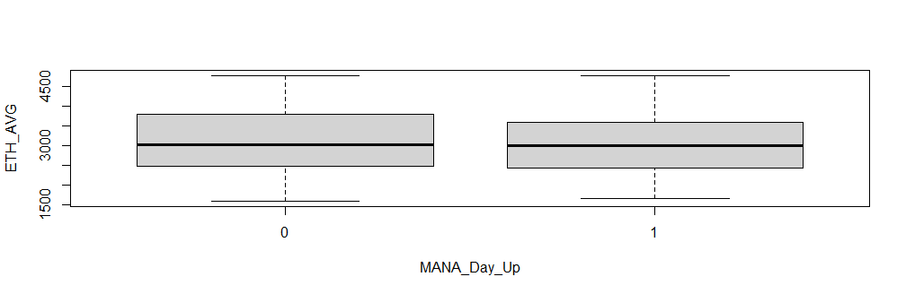

- Can a volume comparison show any details on the coin?
  - It seems the trend in relation to average and volume is positive for MANA where it is a downtrend for the other 2 coins.
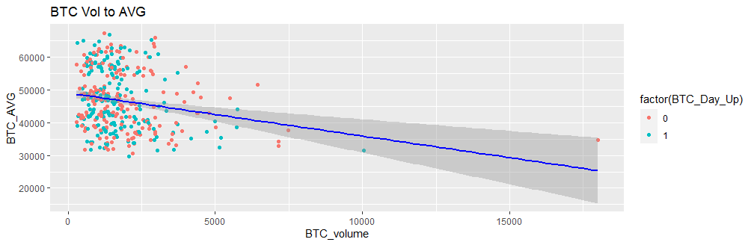
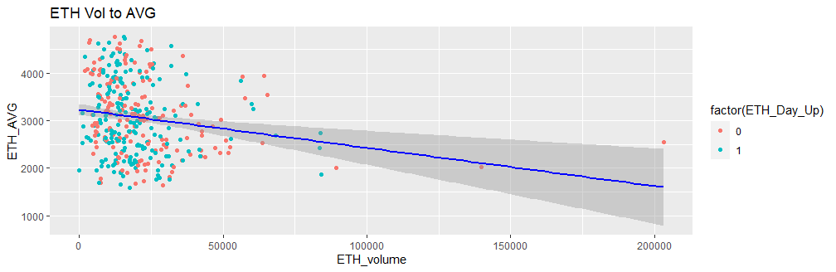
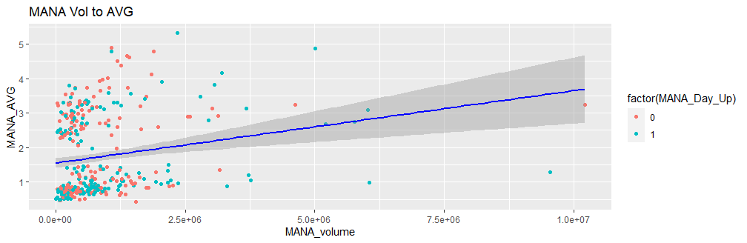

- Was there anything odd about the volume data?
  - Yes.
  - The volume traded for each asset was exponentially lower than what I am used to seeing in an exchange. Other exchanges get upwards of 100k transactions for BTC throughout any year potentially day whereas this exchange only had 18k at the peak.
  - Also, for Mana Nov 7 Coinbase had 616M transactions whereas Gemini (this data) maxed out at a measly 10M.
  - Might need to get other data from another exchange to utilize volume more in relation to price.
- Which asset had the highest and lowest trading volumes?
  - MANA (bottom)
  - BTC(top)
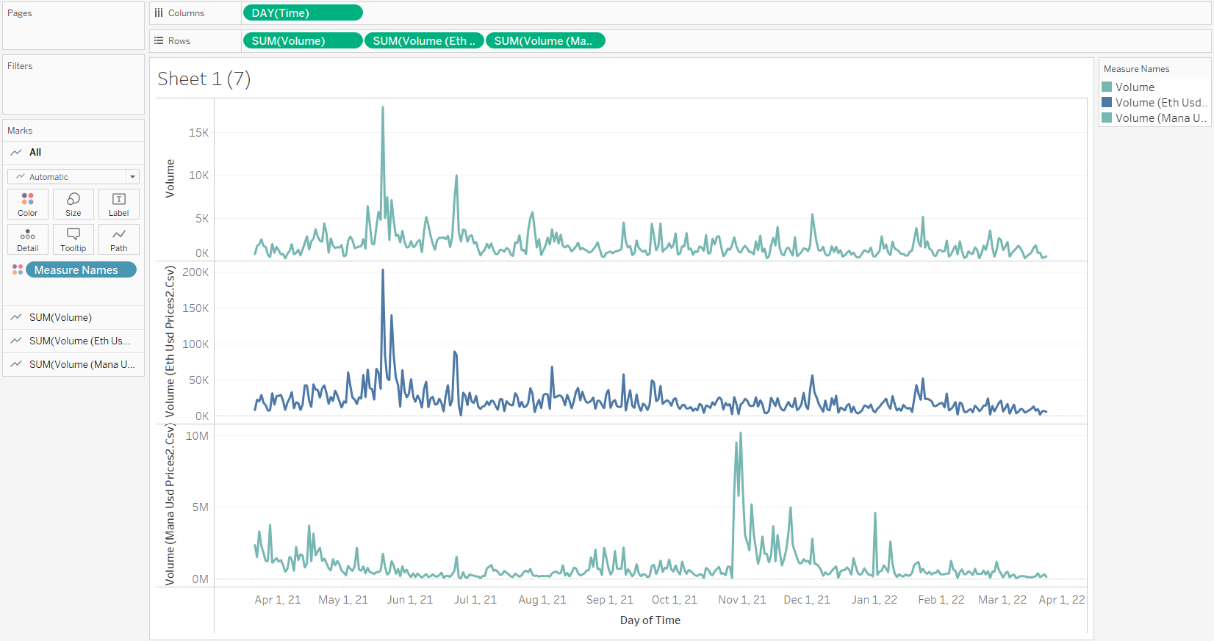
- Can low volume for one asset compromise the data set?
  - Yes, but only if you are not careful, which is why I am going to try and find additional BTC volume data.
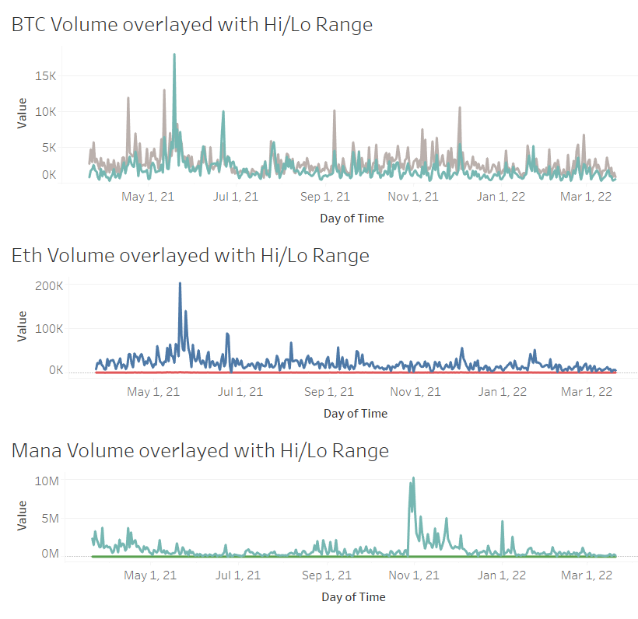
- What days have the biggest fluctuations in price (each days sum for the whole year)?
  - The price might start high but by the end of the day for most day it seems like BTC price ends lower then it started.
  - Monday seems to have the highest daily range for Eth but aside from that its pretty stable through out the week.
  - Seems like Mana likes to alternate up and down days.
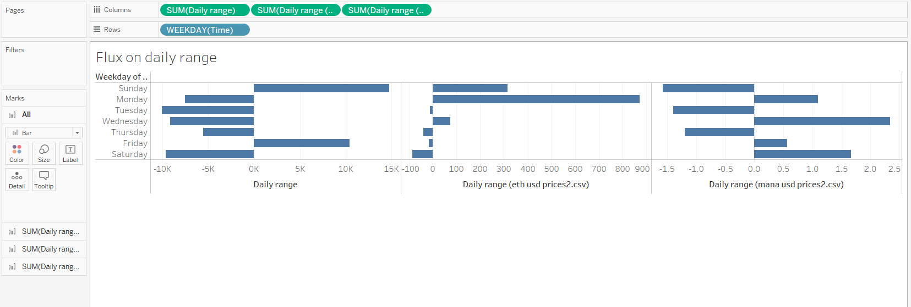
- Is there a specific day that is better than others to purchase crypto assets?
  - It looks like Saturdays have a much lower overall change in highest price to lowest price (price action) between a 24-hour period (crypto trading session is 24 hours a day).
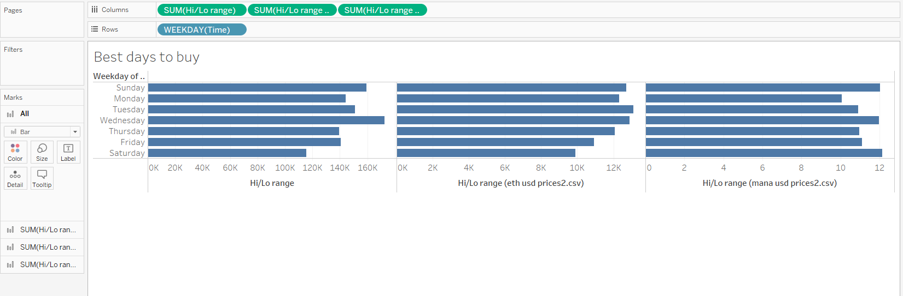
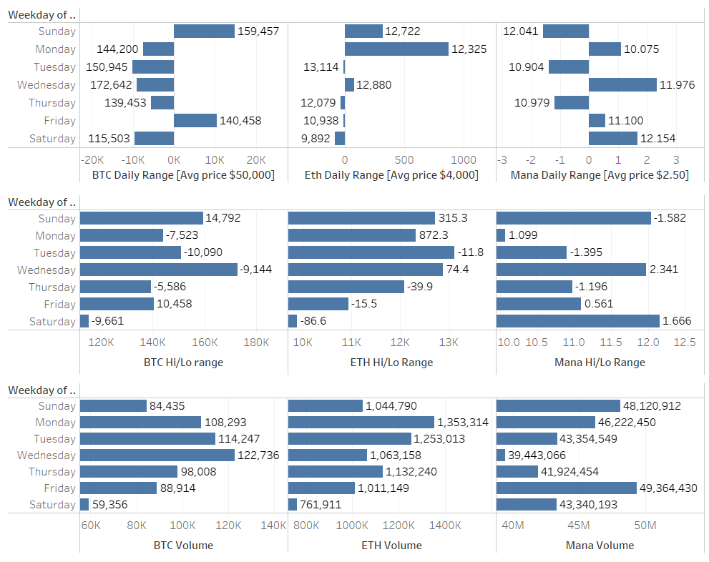
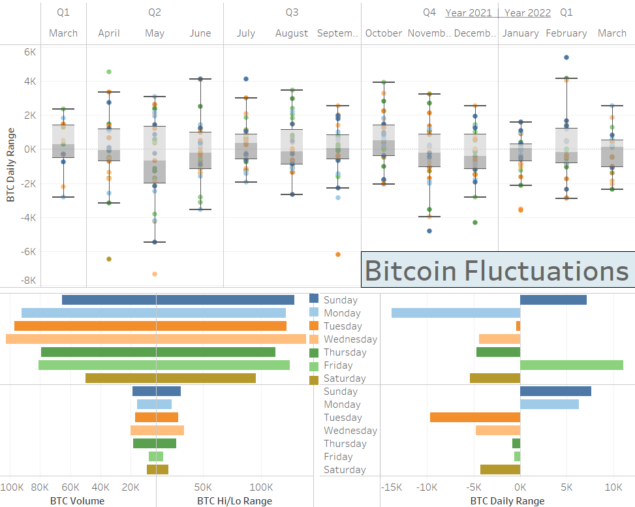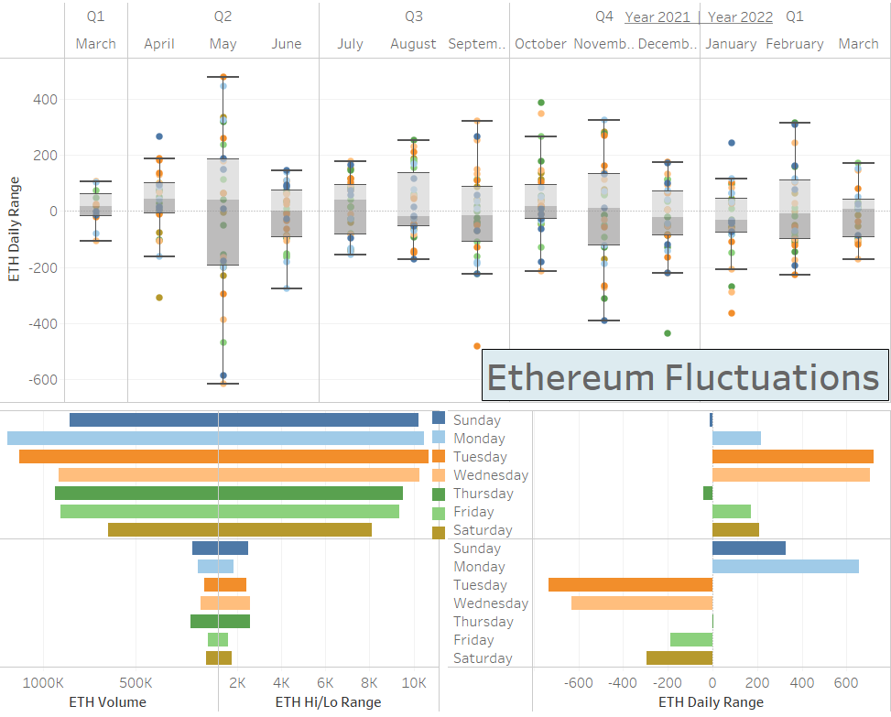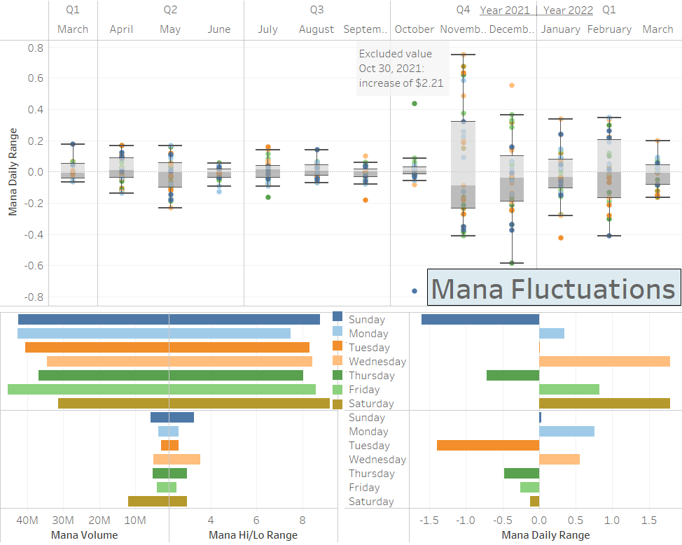

- Is the overall trend of the market going in a positive direction or a negative direction?
  - Since the market is based off BTC, it appears that the overall trend of the mark appears to be in a downward trend.
  - Should be noted that this is just with 1 years’ worth of data from only one exchange so its not a full life cycle view of the alternative currency.
  - Also, since the two trend lines (parabolic lines based off the standard deviation) are crossing it can be determined that there could be is a turnaround or stabilization in the market on the horizon as seen in April 2021. This action could already be underway.
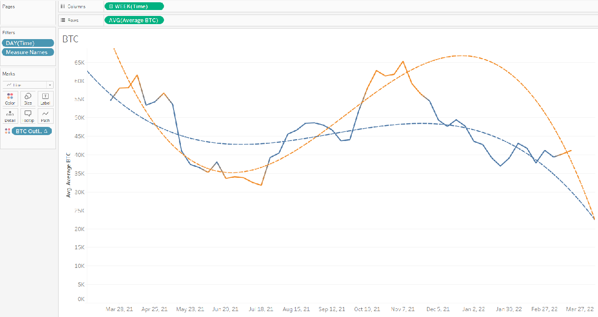
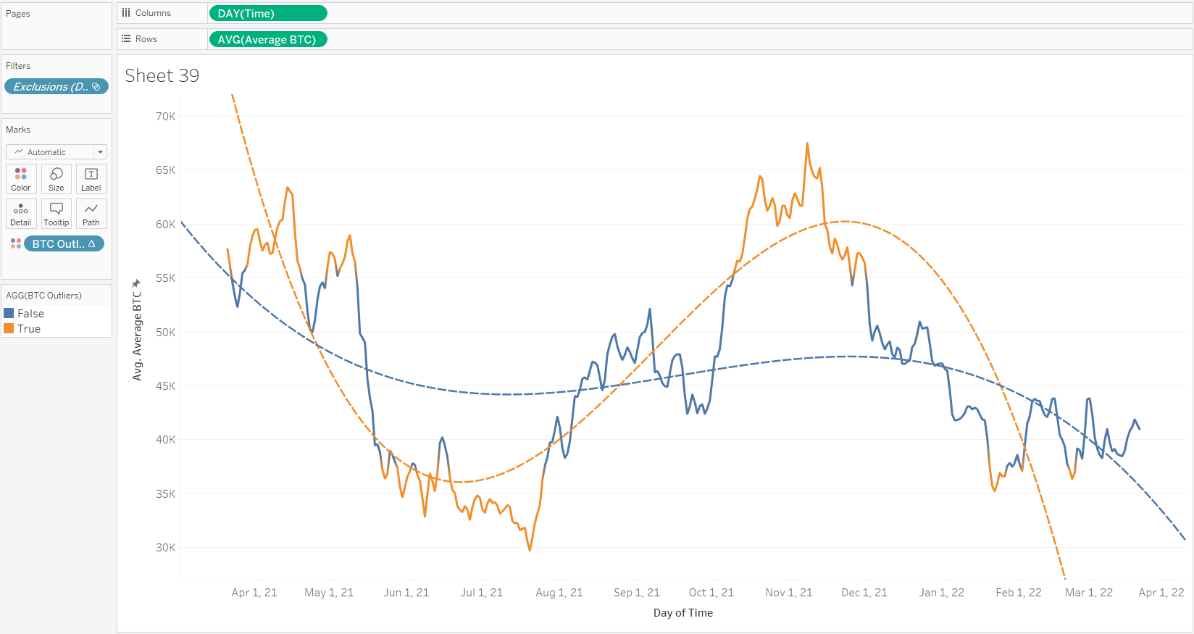
- Where are each Crypto-currencies sitting in reference to their standard deviation?
  - BTC and ETH are laying on the lower end of the SD where as MANA is sitting at the top.
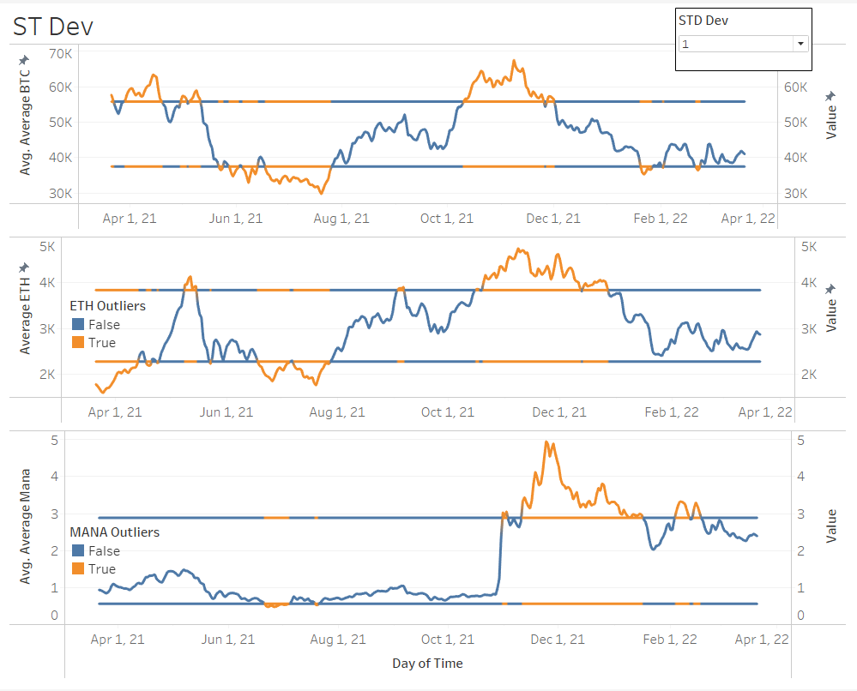
- Which asset within the last 6 months shows positive trends toward growth?
  - BTC and ETH both show very positive growth in relation to their price action.
  - Most of the price action for the two remained well balanced withing the standard deviation with only a few occurrences of outliers.
  - Due to the large spike in MANA from Q4 the parabolic trend lines linked to the standard deviation outliers is pushing for a major downtrend.
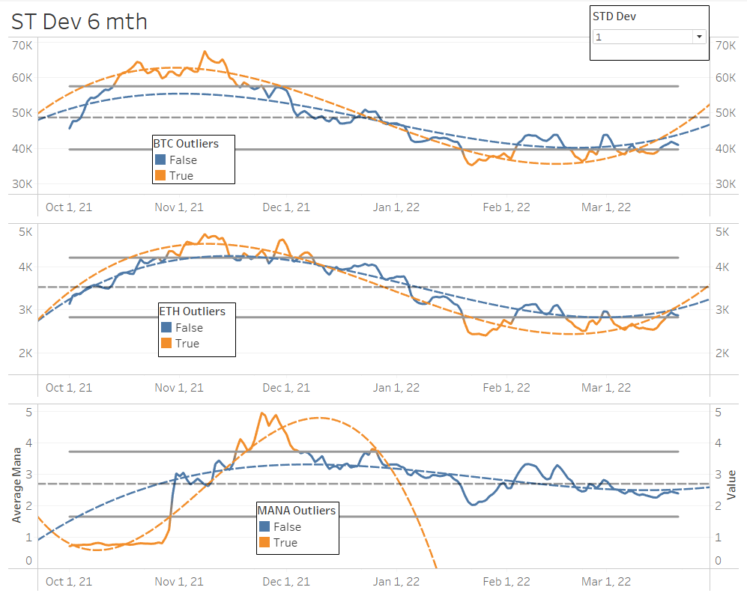
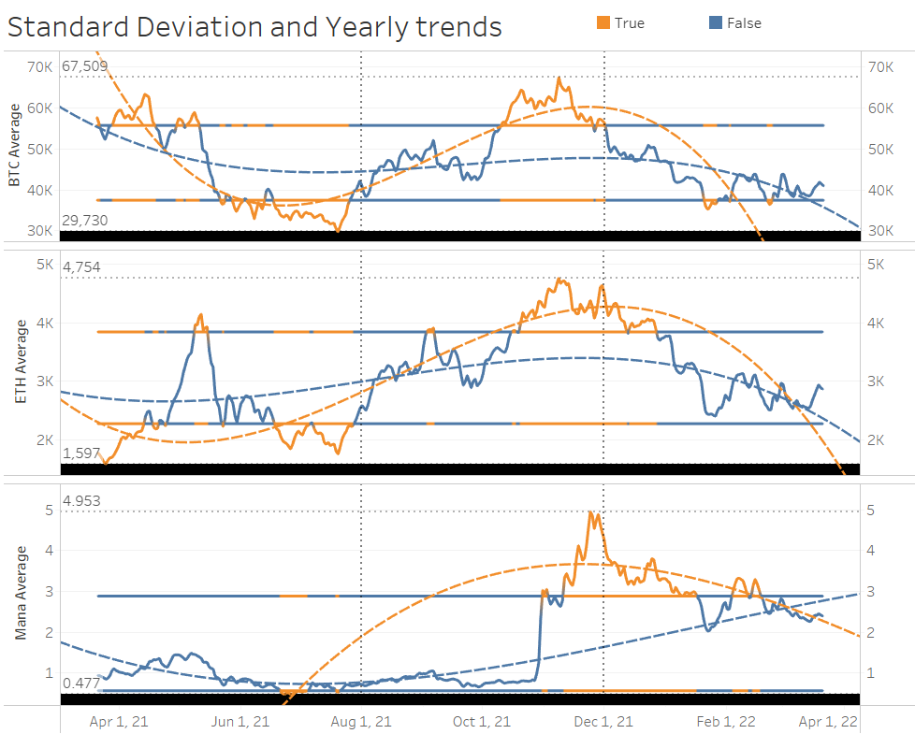
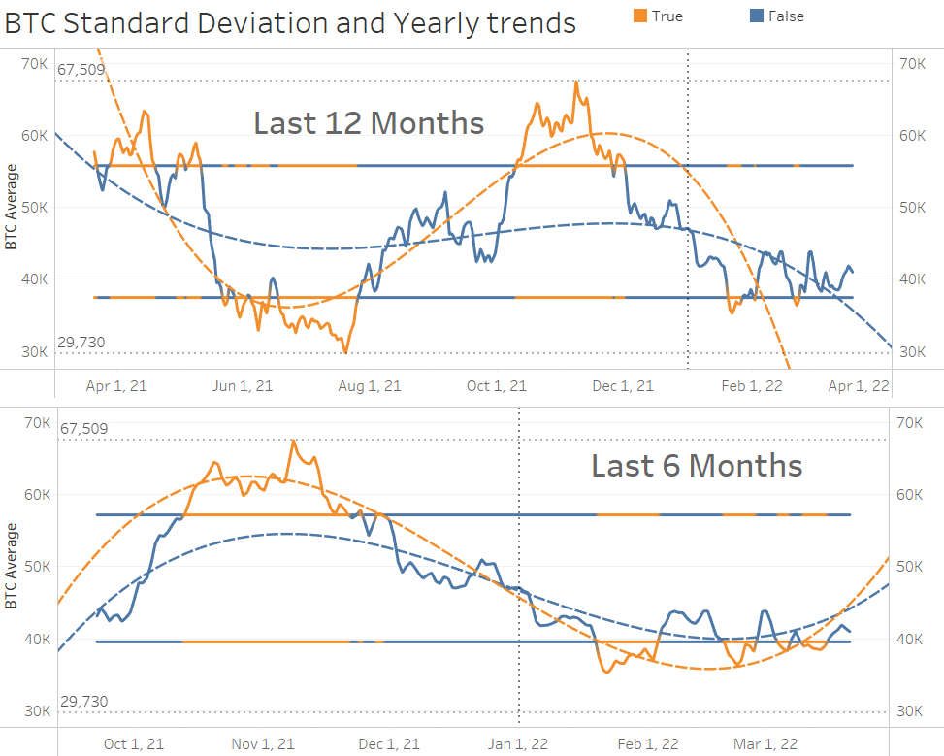
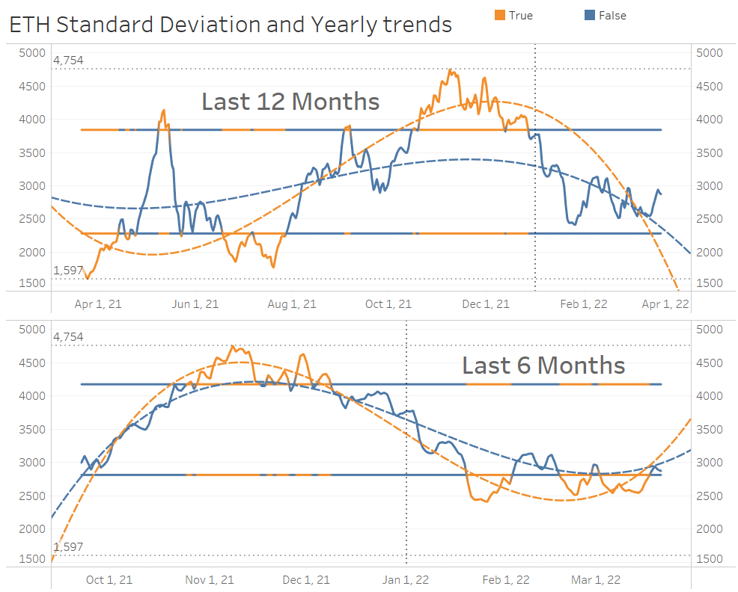
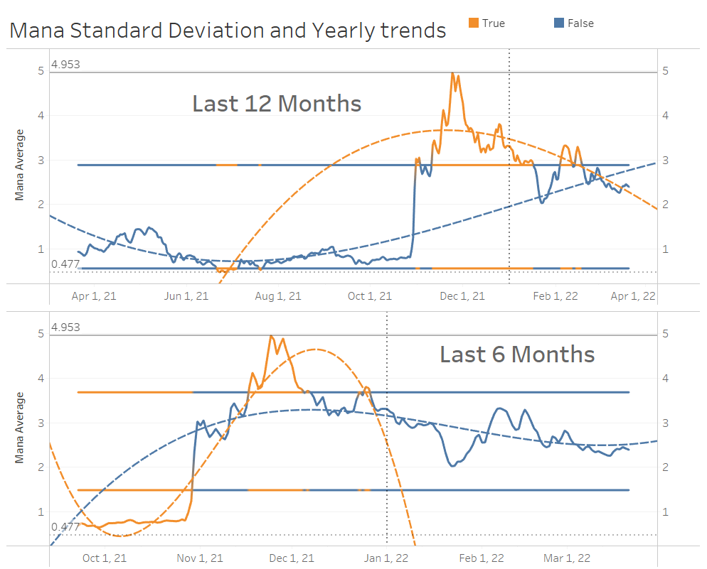
- a Based on the last year which asset has the largest future potential for growth potential?
  - The crypto that would appear to have the highest growth potential would be MANA, it not only surged but it has maintained a higher cost average than BTC and ETH even in a down market.
  - According to the forecasting tools in relation to the calculated average daily cost MANA and BTC look the same in relation to future predictions.
  - ETH on the other hand looks like it could get a large explosion in the short term via the day chart, and Eth and Mana could see substantially more volatility in the coming weeks leading into July.
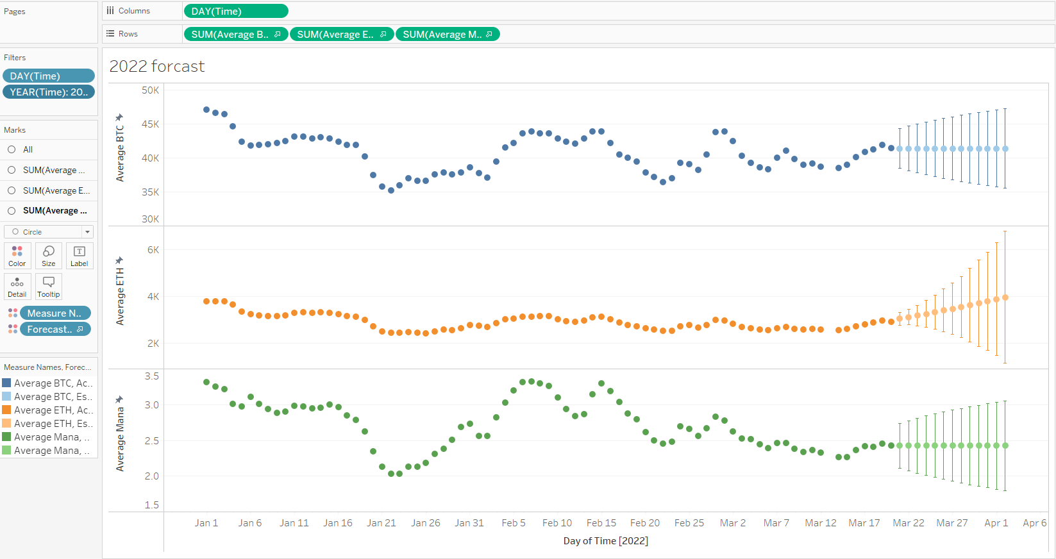
- Instead of by day what about by month?
  - Still clearly looks like Eth and MANA are taking the lead on forecasting in the short term
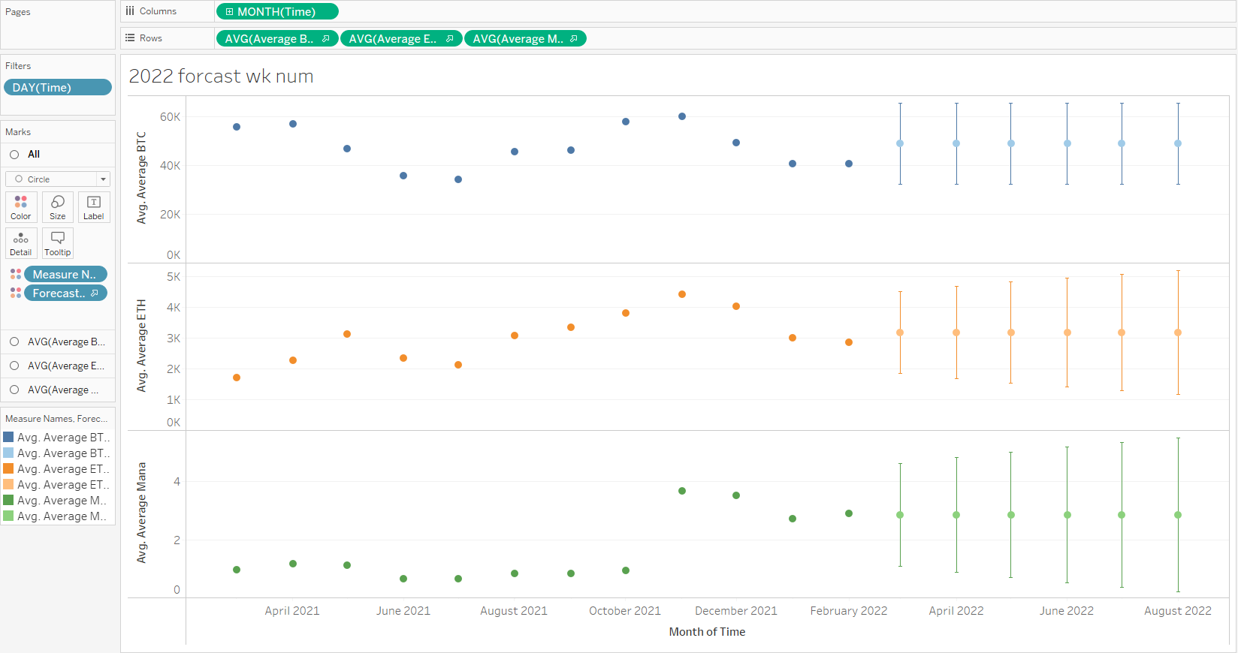

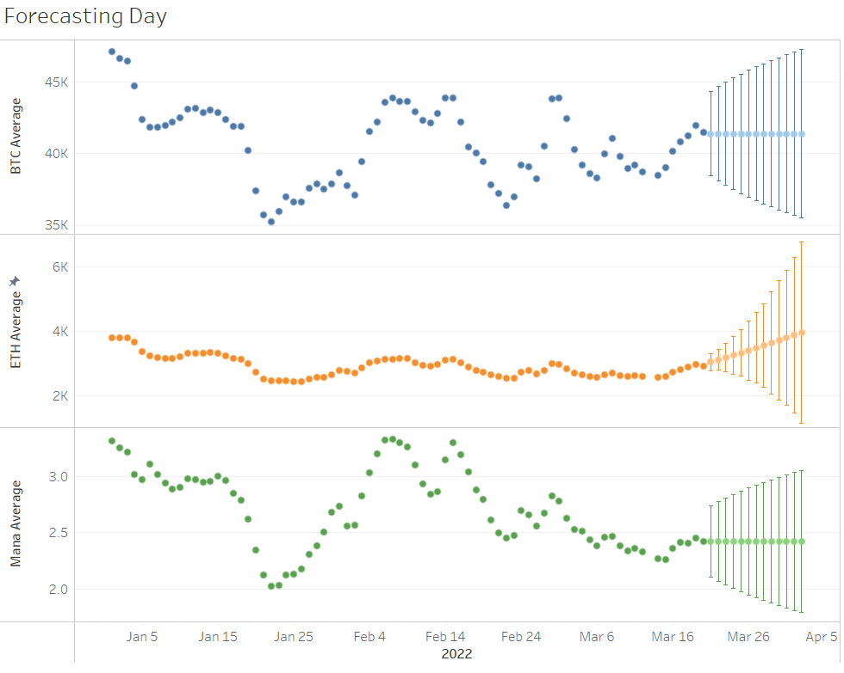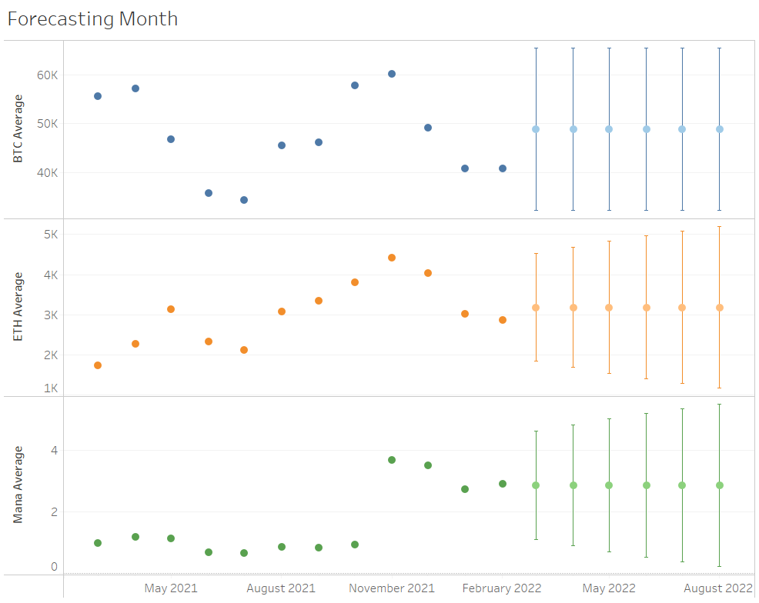
- Is there a crosstab variation with the individual values for the month-based forecasting?
  - This is a numeric version of the monthly forecasting chart provided above.
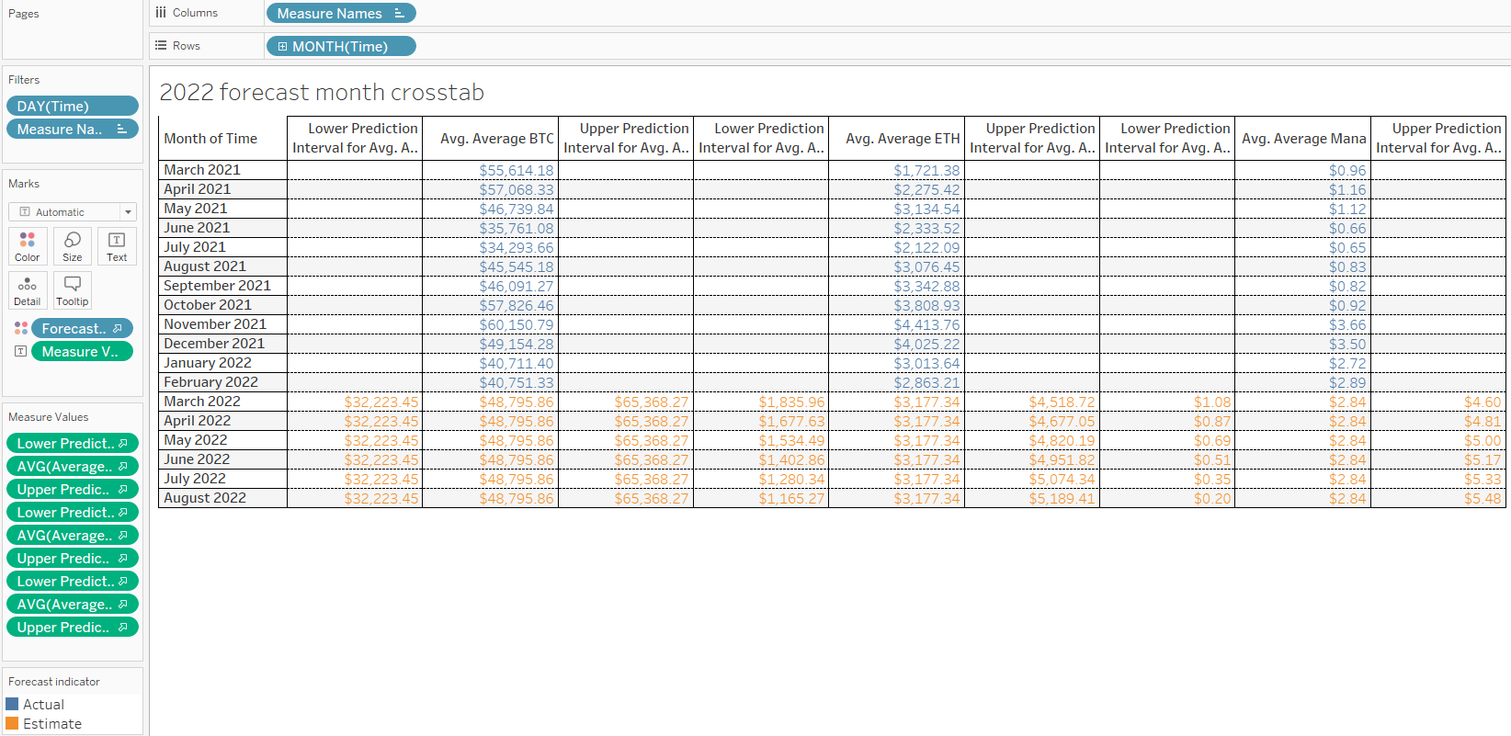

Final statements
When to trade?
- Unlike traditional exchanges cryptocurrency exchanges are open 24/7

- Choosing a trading strategy is tricky because the markets do not close

- Trading strategy for 2022
  - Buy on Monday
  - Sell on Tuesday

- Reasons:
  - The cyclical nature of the main currencies ETH and BTC
  - The weight these main coins carry
  - Plus, the fluctuation metrics we explored
Which to purchase?
Mana
- Had the highest growth over the past year
- Showing stability in holding its new price
- The risk of this asset is still exceedingly high
- Mid range of SD
Bitcoin is the market mover
- Brings buyers to the table for the other assets.
- BTC has some room to significantly increase its current price.
- Currently on the low end of the SD
  - Usually, indicative of a positive bounce.
- Predictive year average sits $10,000 higher than current price
Ethereum
- Out of all assets explored Ethereum seems to be the best asset to hold in general.
- Currently on the low end of the SD
- Positive 6 month forecast
- Well balanced, great distribution
  - Currently below the average
- Stable month over month movements
- Has peaks and valleys but healthy recoveries
BTC and ETH are safe bets with manageable risk and excellent growth capabilities

When Should I buy?
- The data shows the potential for a downturn in the market in the short term
- Purchasing in moderation would be a good idea as a hedge against this theory

Additional plots if needed
Day
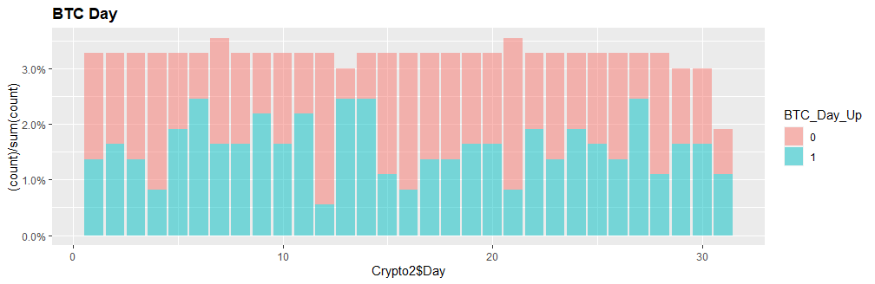
NAVGdistBDay <- ggplot(data=Crypto2, aes(x=Crypto2$Day, fill=BTC_Day_Up)) +
geom_bar(aes(y = (..count..)/sum(..count..)), position='stack', alpha=0.5) + scale_y_continuous(labels=scales::percent)
print(NAVGdistBDay + theme(plot.title=element_text(face="bold")) + ggtitle('BTC Day'))

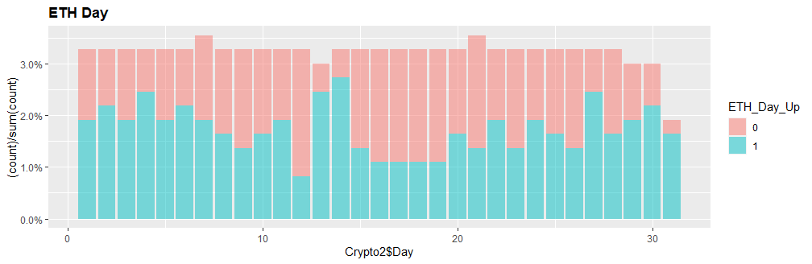
NAVGdistEDay <- ggplot(data=Crypto2, aes(x=Crypto2$Day, fill=ETH_Day_Up)) +
geom_bar(aes(y = (..count..)/sum(..count..)), position='stack', alpha=0.5) + scale_y_continuous(labels=scales::percent)
print(NAVGdistEDay + theme(plot.title=element_text(face="bold")) + ggtitle('ETH Day'))
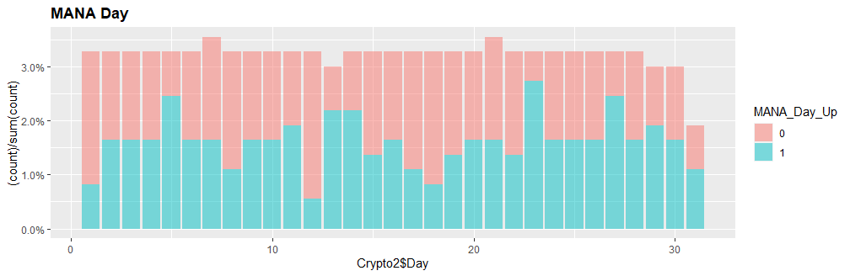
NAVGdistMDay <- ggplot(data=Crypto2, aes(x=Crypto2$Day, fill=MANA_Day_Up)) +
geom_bar(aes(y = (..count..)/sum(..count..)), position='stack', alpha=0.5) + scale_y_continuous(labels=scales::percent)
print(NAVGdistMDay + theme(plot.title=element_text(face="bold")) + ggtitle('MANA Day'))

Weekday
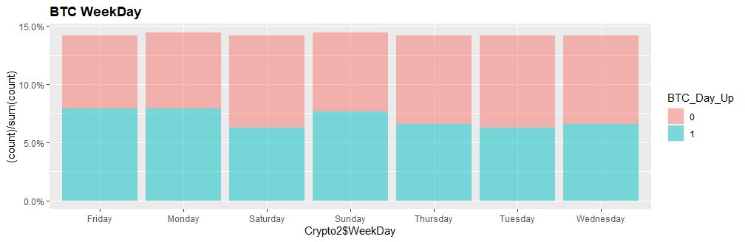
NAVGdistBWeekDay <- ggplot(data=Crypto2, aes(x=Crypto2$WeekDay, fill=BTC_Day_Up)) +
geom_bar(aes(y = (..count..)/sum(..count..)), position='stack', alpha=0.5) + scale_y_continuous(labels=scales::percent)
print(NAVGdistBWeekDay + theme(plot.title=element_text(face="bold")) + ggtitle('BTC WeekDay'))

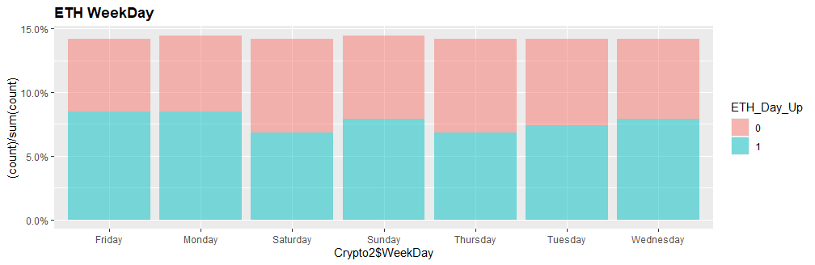
NAVGdistEWeekDay <- ggplot(data=Crypto2, aes(x=Crypto2$WeekDay, fill=ETH_Day_Up)) +
geom_bar(aes(y = (..count..)/sum(..count..)), position='stack', alpha=0.5) + scale_y_continuous(labels=scales::percent)
print(NAVGdistEWeekDay + theme(plot.title=element_text(face="bold")) + ggtitle('ETH WeekDay'))

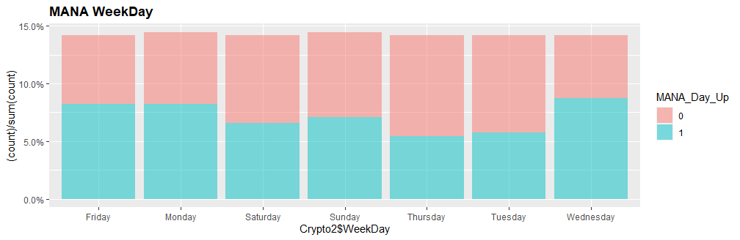
NAVGdistMWeekDay <- ggplot(data=Crypto2, aes(x=Crypto2$WeekDay, fill=MANA_Day_Up)) +
geom_bar(aes(y = (..count..)/sum(..count..)), position='stack', alpha=0.5) + scale_y_continuous(labels=scales::percent)
print(NAVGdistMWeekDay + theme(plot.title=element_text(face="bold")) + ggtitle('MANA WeekDay'))

Month View
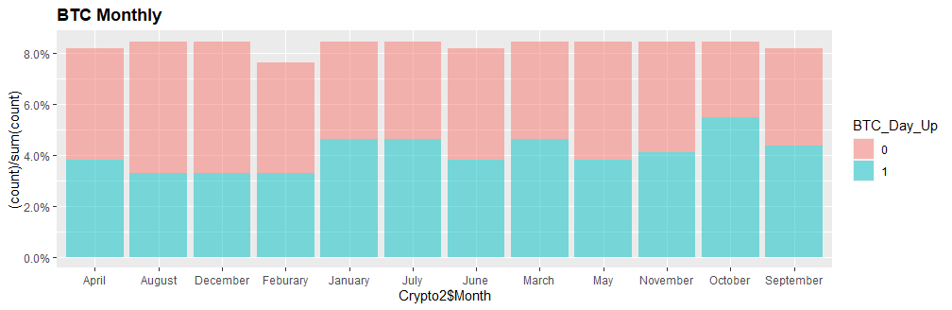
NAVGdistBMonth <- ggplot(data=Crypto2, aes(x=Crypto2$Month, fill=BTC_Day_Up)) +
geom_bar(aes(y = (..count..)/sum(..count..)), position='stack', alpha=0.5) + scale_y_continuous(labels=scales::percent)
print(NAVGdistBMonth + theme(plot.title=element_text(face="bold")) + ggtitle('BTC Monthly'))

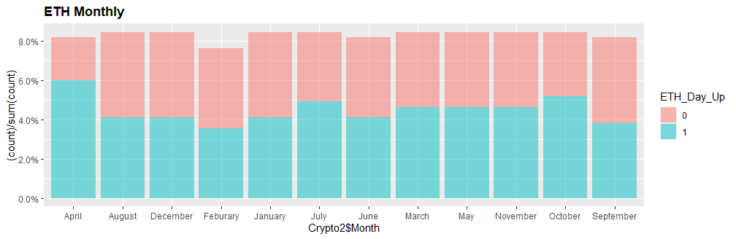
NAVGdistEMonth <- ggplot(data=Crypto2, aes(x=Crypto2$Month, fill=ETH_Day_Up)) +
geom_bar(aes(y = (..count..)/sum(..count..)), position='stack', alpha=0.5) + scale_y_continuous(labels=scales::percent)
print(NAVGdistEMonth + theme(plot.title=element_text(face="bold")) + ggtitle('ETH Monthly'))
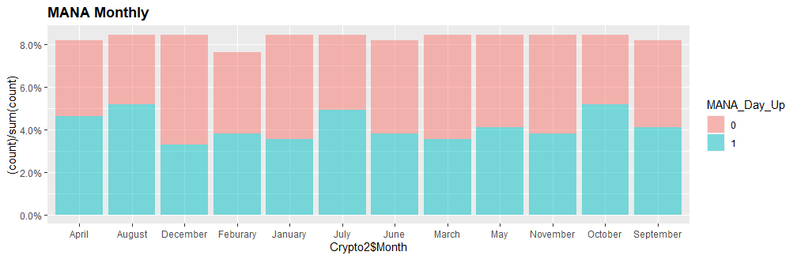
NAVGdistMMonth <- ggplot(data=Crypto2, aes(x=Crypto2$Month, fill=MANA_Day_Up)) +
geom_bar(aes(y = (..count..)/sum(..count..)), position='stack', alpha=0.5) + scale_y_continuous(labels=scales::percent)
print(NAVGdistMMonth + theme(plot.title=element_text(face="bold")) + ggtitle('MANA Monthly'))

YEAR

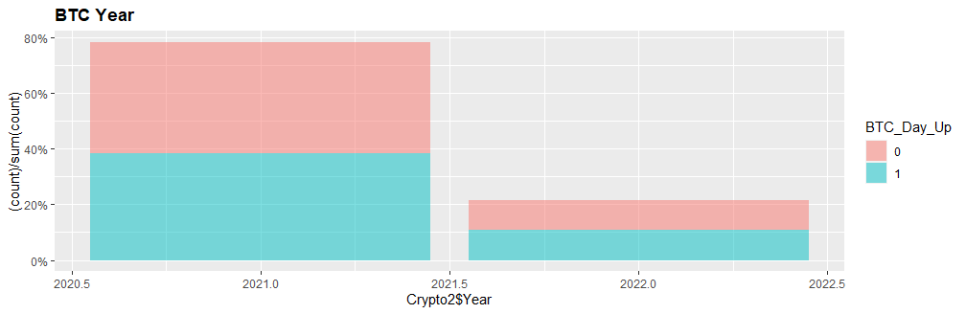
NAVGdistBYear <- ggplot(data=Crypto2, aes(x=Crypto2$Year, fill=BTC_Day_Up)) +
geom_bar(aes(y = (..count..)/sum(..count..)), position='stack', alpha=0.5) + scale_y_continuous(labels=scales::percent)
print(NAVGdistBYear + theme(plot.title=element_text(face="bold")) + ggtitle('BTC Year'))

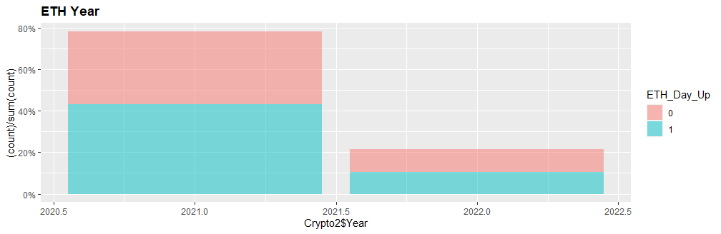
NAVGdistEYear <- ggplot(data=Crypto2, aes(x=Crypto2$Year, fill=ETH_Day_Up)) +
geom_bar(aes(y = (..count..)/sum(..count..)), position='stack', alpha=0.5) + scale_y_continuous(labels=scales::percent)
print(NAVGdistEYear + theme(plot.title=element_text(face="bold")) + ggtitle('ETH Year'))

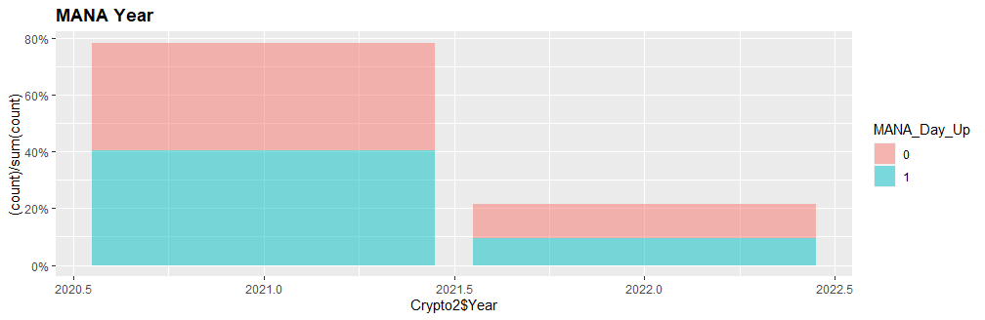
NAVGdistMYear <- ggplot(data=Crypto2, aes(x=Crypto2$Year, fill=MANA_Day_Up)) +
geom_bar(aes(y = (..count..)/sum(..count..)), position='stack', alpha=0.5) + scale_y_continuous(labels=scales::percent)
print(NAVGdistMYear + theme(plot.title=element_text(face="bold")) + ggtitle('MANA Year'))

Reference

*Edwards, John. “Bitcoin’s Price History.” Investopedia, Feb. 2022, https://www.investopedia.com/articles/forex/121815/bitcoins-price-history.asp.

