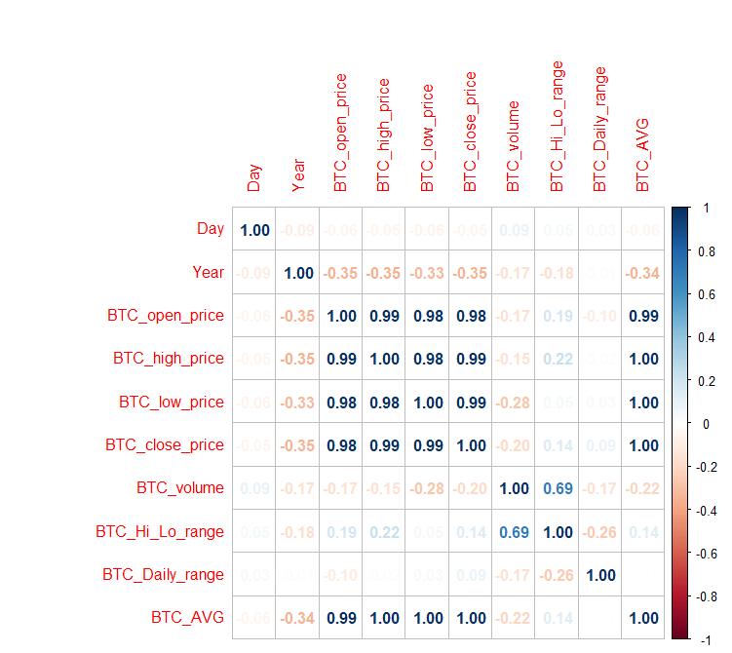

corVizBTC <- select(CData, Date,Day,WeekDay,Month,Year,BTC_open_price,BTC_high_price,BTC_low_price,BTC_close_price,BTC_volume,BTC_Hi_Lo_range,BTC_Daily_range,BTC_AVG)
str(corVizBTC)
corVizBTC$Day <- as.numeric(corVizBTC$DAY)
corVizBTC$Year <- as.numeric(corVizBTC$Year)

numcolBTC <- sapply(corVizBTC,is.numeric)
pearsoncorBTC <- cor(corVizBTC[numcolBTC], use="complete.obs")
corrplot(pearsoncorBTC, "number")

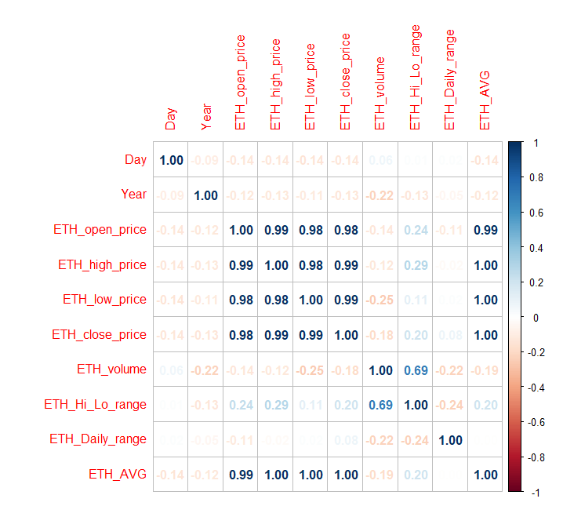

corVizETH <- select(CData, Date,Day,WeekDay,Month,Year,ETH_open_price,ETH_high_price,ETH_low_price,ETH_close_price,ETH_volume,ETH_Hi_Lo_range,ETH_Daily_range,ETH_AVG)
str(corVizETH)
corVizETH$Day <- as.numeric(corVizETH$DAY)
corVizETH$Year <- as.numeric(corVizETH$Year)
numcolETH <- sapply(corVizETH,is.numeric)
pearsoncorETH <- cor(corVizETH[numcolETH], use="complete.obs")
corrplot(pearsoncorETH, "number")

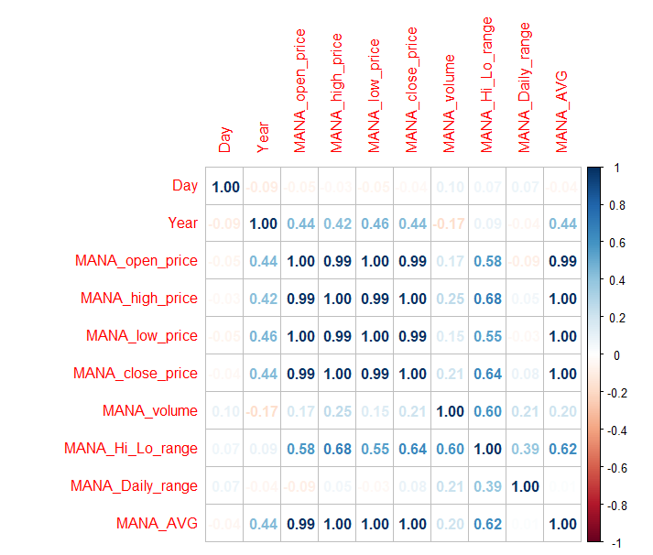

corVizMANA <- select(CData, Date,Day,WeekDay,Month,Year,MANA_open_price,MANA_high_price,MANA_low_price,MANA_close_price,MANA_volume,MANA_Hi_Lo_range,MANA_Daily_range,MANA_AVG)
str(corVizMANA)
corVizMANA$Day <- as.numeric(corVizMANA$DAY)
corVizMANA$Year <- as.numeric(corVizMANA$Year)
numcolMANA <- sapply(corVizMANA,is.numeric)
pearsoncorMANA <- cor(corVizMANA[numcolMANA], use="complete.obs")
corrplot(pearsoncorMANA, "number")

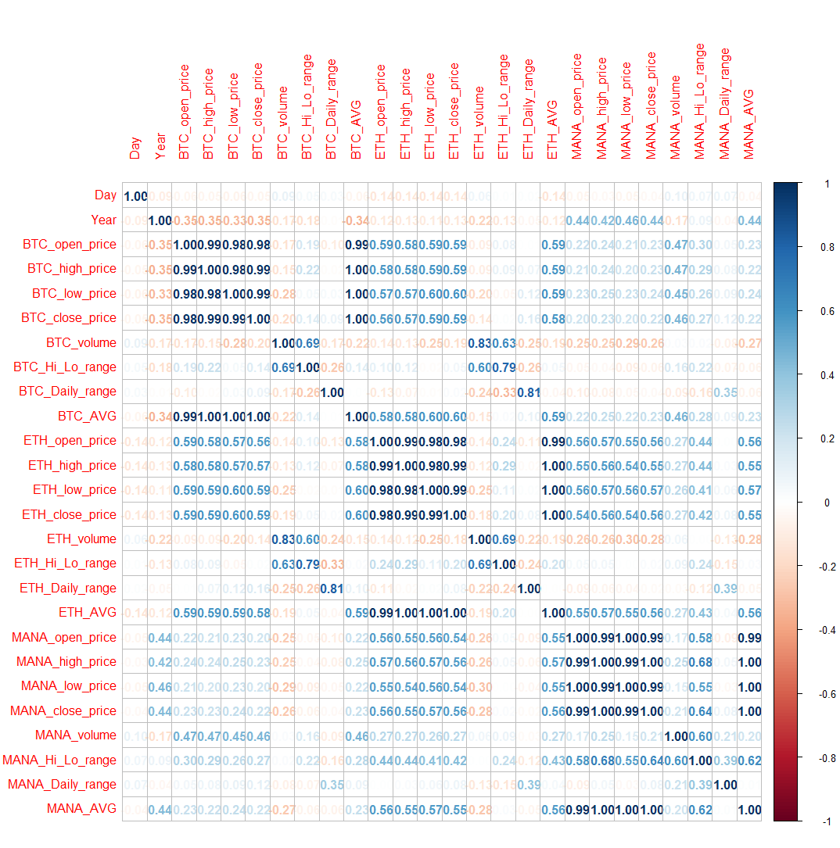

corVizAll <- select(CData, Date,Day,WeekDay,Month,Year,BTC_open_price,BTC_high_price,BTC_low_price,BTC_close_price,BTC_volume,BTC_Hi_Lo_range,BTC_Daily_range,BTC_AVG,ETH_open_price,ETH_high_price,ETH_low_price,ETH_close_price,ETH_volume,ETH_Hi_Lo_range,ETH_Daily_range,ETH_AVG,MANA_open_price,MANA_high_price,MANA_low_price,MANA_close_price,MANA_volume,MANA_Hi_Lo_range,MANA_Daily_range,MANA_AVG)
str(corVizAll)
corVizAll$Day <- as.numeric(corVizAll$DAY)
corVizAll$Year <- as.numeric(corVizAll$Year)
numcolAll <- sapply(corVizAll,is.numeric)
pearsoncorAll <- cor(corVizAll[numcolAll], use="complete.obs")
corrplot(pearsoncorAll, "number")

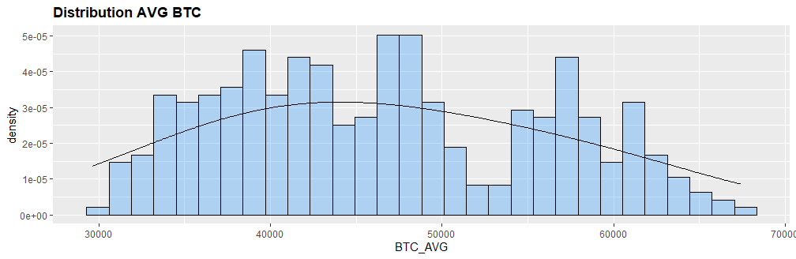

DViz <- ggplot(data=CData, aes(x=BTC_AVG)) +
geom_histogram(aes(y=..density..),
col='black',
fill='dodgerblue1',
alpha=0.3) +
geom_density(adjust=3)
print(DViz + theme(plot.title=element_text(face="bold")) + ggtitle('Distribution AVG BTC'))

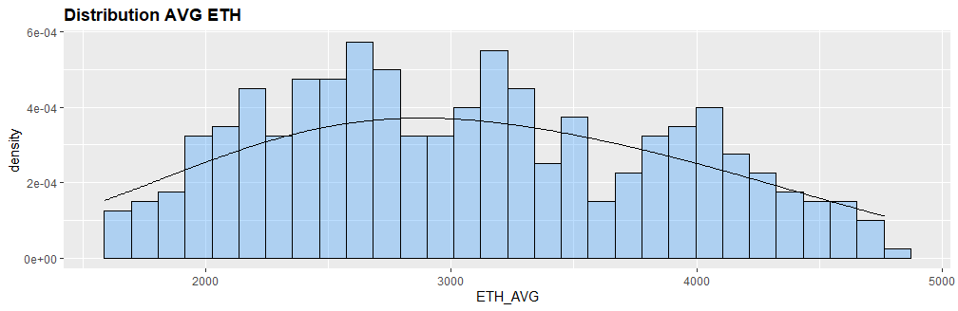

DViz <- ggplot(data=CData, aes(x=ETH_AVG)) +
geom_histogram(aes(y=..density..),
col='black',
fill='dodgerblue1',
alpha=0.3) +
geom_density(adjust=3)
print(DViz + theme(plot.title=element_text(face="bold")) + ggtitle('Distribution AVG ETH'))

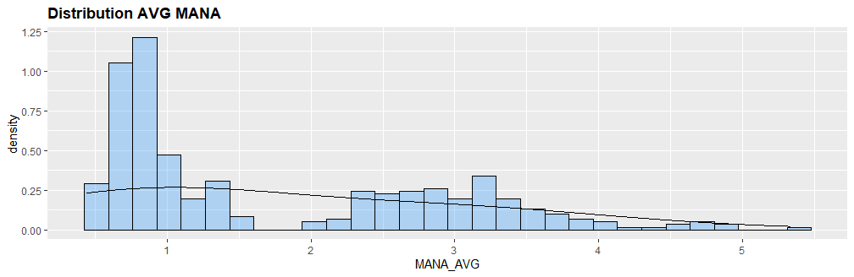

DVizMANA <- ggplot(data=CData, aes(x=MANA_AVG)) +
geom_histogram(aes(y=..density..),
col='black',
fill='dodgerblue1',
alpha=0.3) +
geom_density(adjust=3)
print(DVizMANA + theme(plot.title=element_text(face="bold")) + ggtitle('Distribution AVG MANA'))

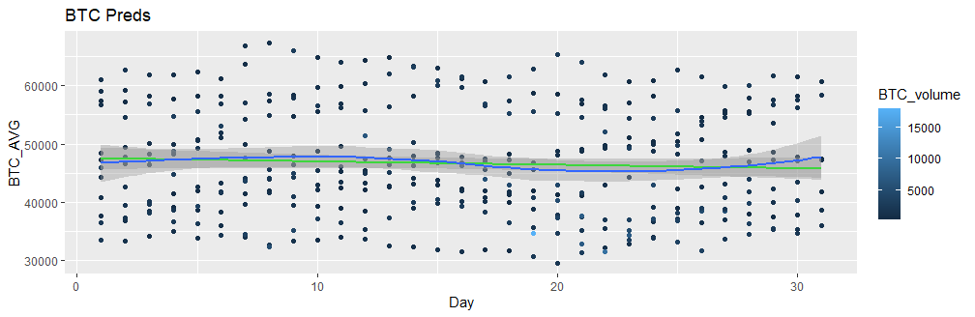

ggplot(data=CData, aes(x=Day,y=BTC_AVG,color=BTC_volume))+
geom_point()+
stat_smooth(method= "lm", col = "green")+
geom_smooth()+
ggtitle('BTC Preds')
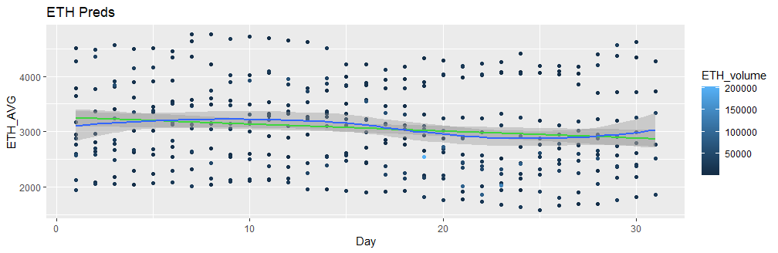

ggplot(data=CData, aes(x=Day,y=BTC_AVG,color=BTC_volume))+
geom_point()+
stat_smooth(method= "lm", col = "green")+
geom_smooth()+
ggtitle('BTC Preds')

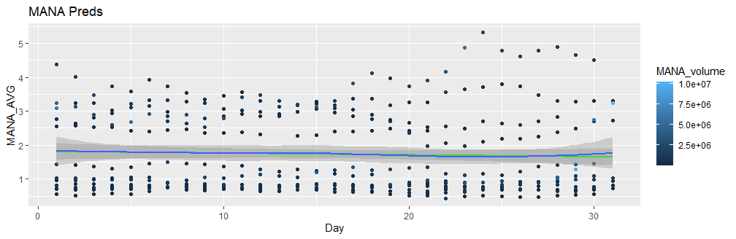
ggplot(data=CData, aes(x=Day,y=MANA_AVG,color=MANA_volume))+
geom_point()+
stat_smooth(method= "lm", col = "green")+
geom_smooth()+
ggtitle('MANA Preds')

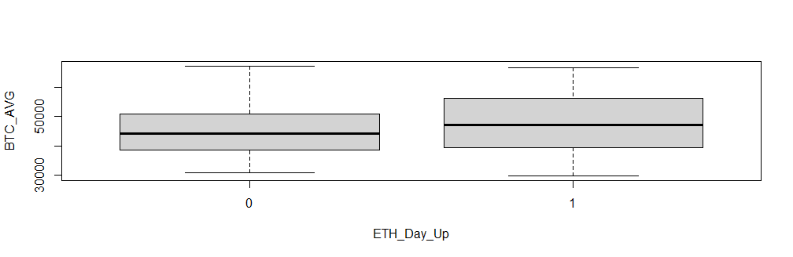

plot(BTC_AVG ~ ETH_Day_Up, data=Crypto2)

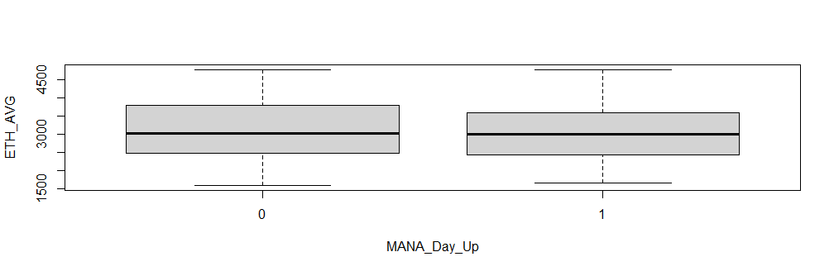

plot(ETH_AVG ~ MANA_Day_Up, data=Crypto2)

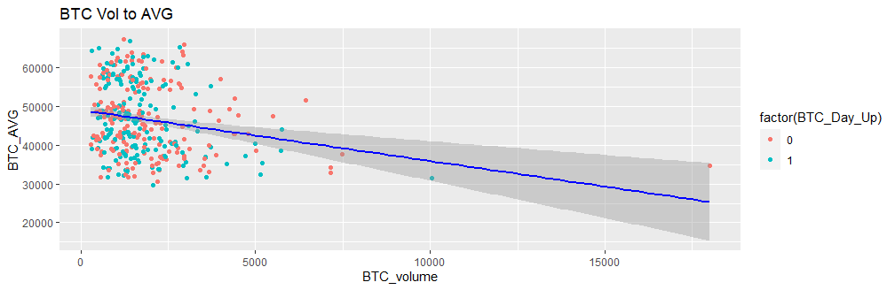
ggplot(Crypto2, aes(x = BTC_volume, y = BTC_AVG)) +
geom_point(aes(color = factor(BTC_Day_Up))) +
stat_smooth(method = "lm", col = "blue")+
labs(title="BTC Vol to AVG")
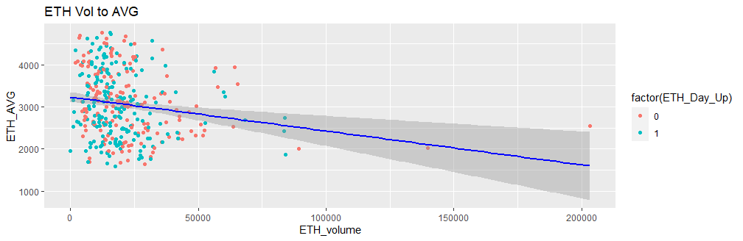
ggplot(Crypto2, aes(x = ETH_volume, y = ETH_AVG)) +
geom_point(aes(color = factor(ETH_Day_Up))) +
stat_smooth(method = "lm", col = "blue")+
labs(title="ETH Vol to AVG")

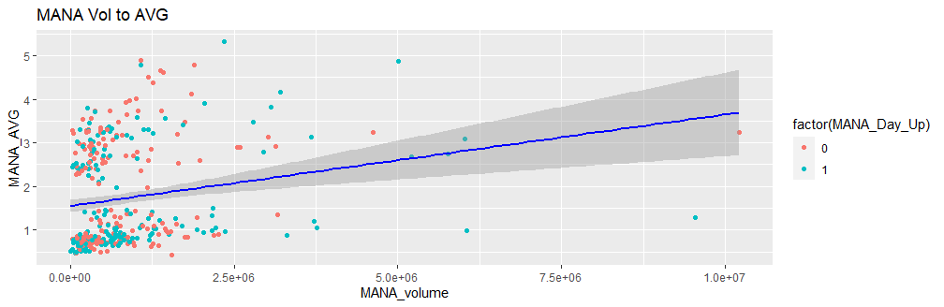
ggplot(Crypto2, aes(x = MANA_volume, y = MANA_AVG)) +
geom_point(aes(color = factor(MANA_Day_Up))) +
stat_smooth(method = "lm", col = "blue")+
labs(title="MANA Vol to AVG")

Day
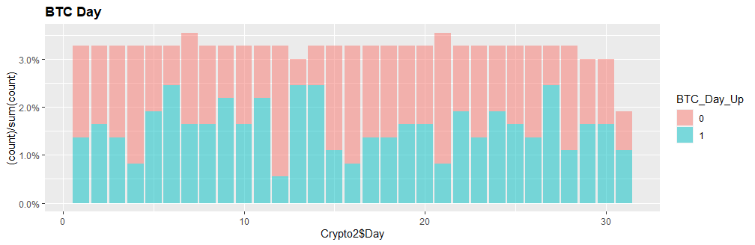
NAVGdistBDay <- ggplot(data=Crypto2, aes(x=Crypto2$Day, fill=BTC_Day_Up)) +
geom_bar(aes(y = (..count..)/sum(..count..)), position='stack', alpha=0.5) + scale_y_continuous(labels=scales::percent)
print(NAVGdistBDay + theme(plot.title=element_text(face="bold")) + ggtitle('BTC Day'))

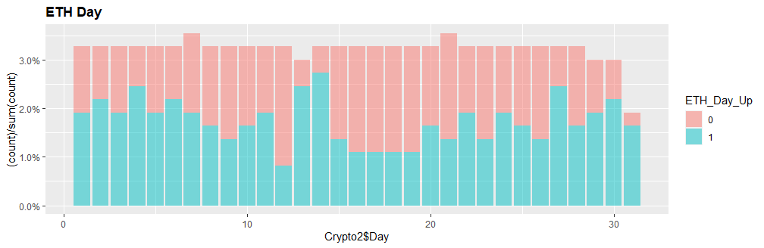
NAVGdistEDay <- ggplot(data=Crypto2, aes(x=Crypto2$Day, fill=ETH_Day_Up)) +
geom_bar(aes(y = (..count..)/sum(..count..)), position='stack', alpha=0.5) + scale_y_continuous(labels=scales::percent)
print(NAVGdistEDay + theme(plot.title=element_text(face="bold")) + ggtitle('ETH Day'))
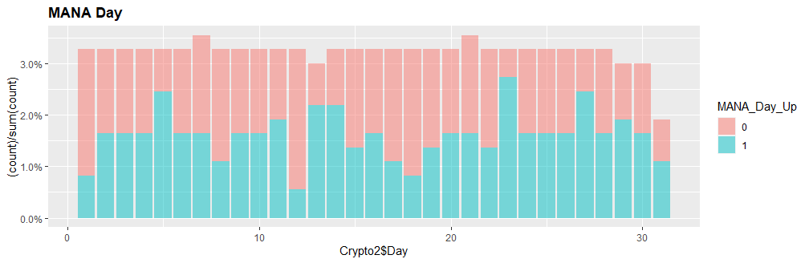
NAVGdistMDay <- ggplot(data=Crypto2, aes(x=Crypto2$Day, fill=MANA_Day_Up)) +
geom_bar(aes(y = (..count..)/sum(..count..)), position='stack', alpha=0.5) + scale_y_continuous(labels=scales::percent)
print(NAVGdistMDay + theme(plot.title=element_text(face="bold")) + ggtitle('MANA Day'))

Weekday
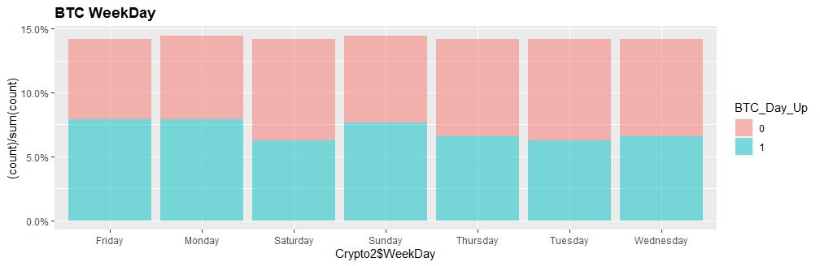
NAVGdistBWeekDay <- ggplot(data=Crypto2, aes(x=Crypto2$WeekDay, fill=BTC_Day_Up)) +
geom_bar(aes(y = (..count..)/sum(..count..)), position='stack', alpha=0.5) + scale_y_continuous(labels=scales::percent)
print(NAVGdistBWeekDay + theme(plot.title=element_text(face="bold")) + ggtitle('BTC WeekDay'))

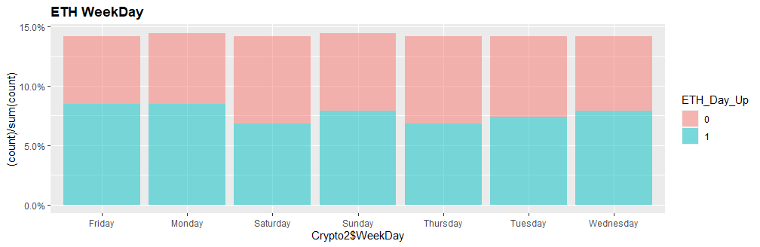
NAVGdistEWeekDay <- ggplot(data=Crypto2, aes(x=Crypto2$WeekDay, fill=ETH_Day_Up)) +
geom_bar(aes(y = (..count..)/sum(..count..)), position='stack', alpha=0.5) + scale_y_continuous(labels=scales::percent)
print(NAVGdistEWeekDay + theme(plot.title=element_text(face="bold")) + ggtitle('ETH WeekDay'))

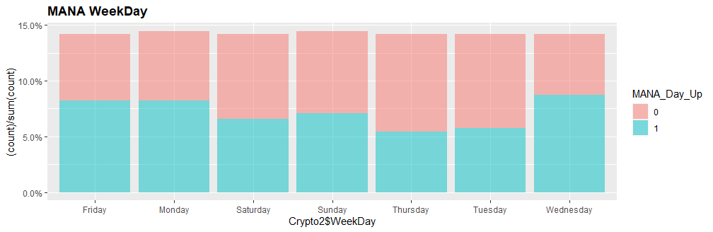
NAVGdistMWeekDay <- ggplot(data=Crypto2, aes(x=Crypto2$WeekDay, fill=MANA_Day_Up)) +
geom_bar(aes(y = (..count..)/sum(..count..)), position='stack', alpha=0.5) + scale_y_continuous(labels=scales::percent)
print(NAVGdistMWeekDay + theme(plot.title=element_text(face="bold")) + ggtitle('MANA WeekDay'))

Month View
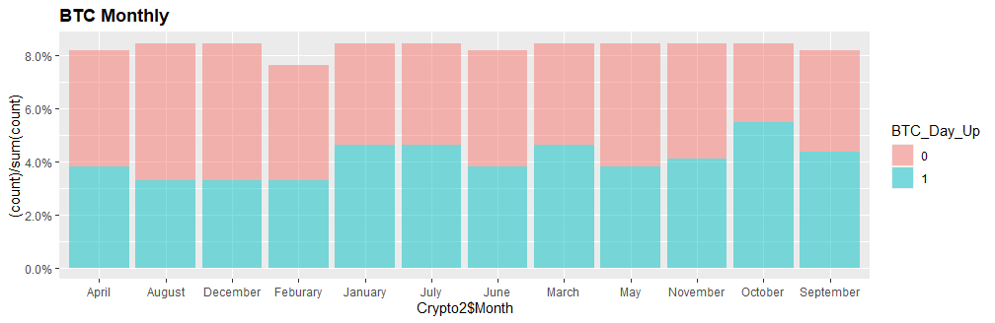
NAVGdistBMonth <- ggplot(data=Crypto2, aes(x=Crypto2$Month, fill=BTC_Day_Up)) +
geom_bar(aes(y = (..count..)/sum(..count..)), position='stack', alpha=0.5) + scale_y_continuous(labels=scales::percent)
print(NAVGdistBMonth + theme(plot.title=element_text(face="bold")) + ggtitle('BTC Monthly'))

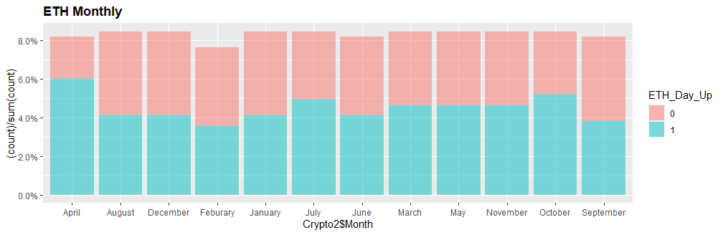
NAVGdistEMonth <- ggplot(data=Crypto2, aes(x=Crypto2$Month, fill=ETH_Day_Up)) +
geom_bar(aes(y = (..count..)/sum(..count..)), position='stack', alpha=0.5) + scale_y_continuous(labels=scales::percent)
print(NAVGdistEMonth + theme(plot.title=element_text(face="bold")) + ggtitle('ETH Monthly'))
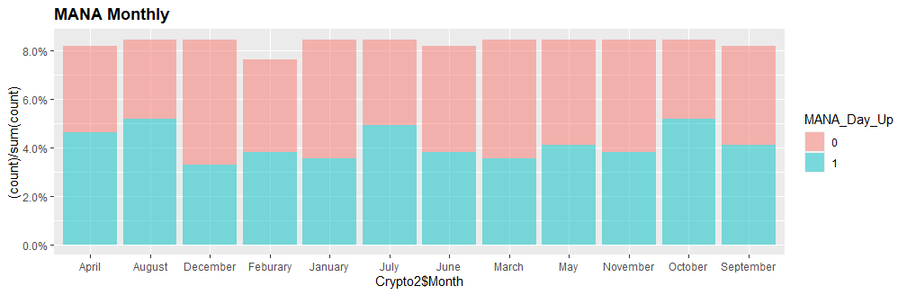
NAVGdistMMonth <- ggplot(data=Crypto2, aes(x=Crypto2$Month, fill=MANA_Day_Up)) +
geom_bar(aes(y = (..count..)/sum(..count..)), position='stack', alpha=0.5) + scale_y_continuous(labels=scales::percent)
print(NAVGdistMMonth + theme(plot.title=element_text(face="bold")) + ggtitle('MANA Monthly'))

YEAR

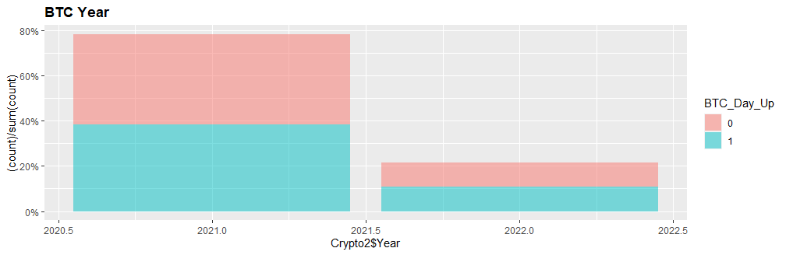
NAVGdistBYear <- ggplot(data=Crypto2, aes(x=Crypto2$Year, fill=BTC_Day_Up)) +
geom_bar(aes(y = (..count..)/sum(..count..)), position='stack', alpha=0.5) + scale_y_continuous(labels=scales::percent)
print(NAVGdistBYear + theme(plot.title=element_text(face="bold")) + ggtitle('BTC Year'))

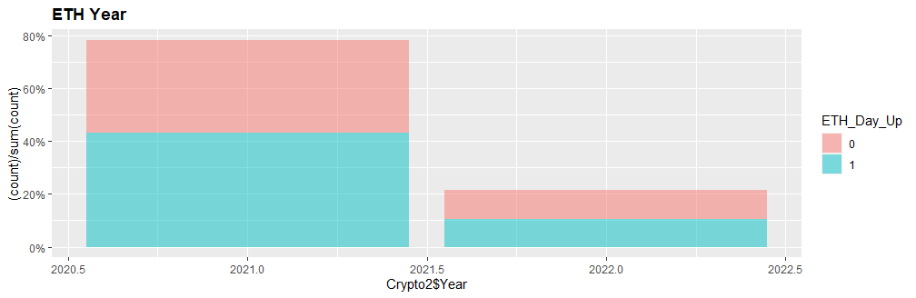
NAVGdistEYear <- ggplot(data=Crypto2, aes(x=Crypto2$Year, fill=ETH_Day_Up)) +
geom_bar(aes(y = (..count..)/sum(..count..)), position='stack', alpha=0.5) + scale_y_continuous(labels=scales::percent)
print(NAVGdistEYear + theme(plot.title=element_text(face="bold")) + ggtitle('ETH Year'))

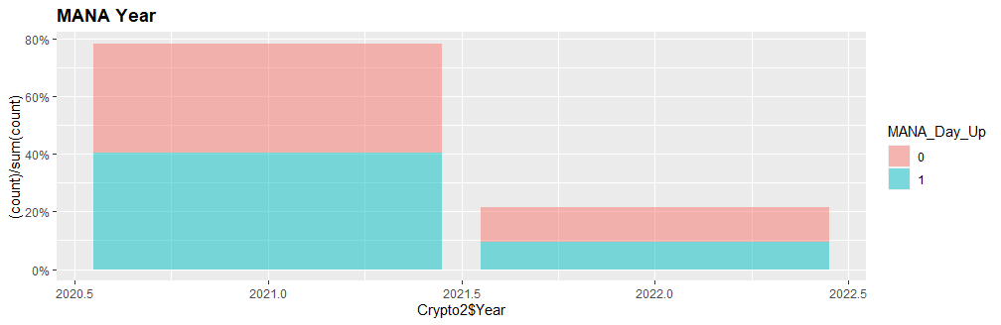
NAVGdistMYear <- ggplot(data=Crypto2, aes(x=Crypto2$Year, fill=MANA_Day_Up)) +
geom_bar(aes(y = (..count..)/sum(..count..)), position='stack', alpha=0.5) + scale_y_continuous(labels=scales::percent)
print(NAVGdistMYear + theme(plot.title=element_text(face="bold")) + ggtitle('MANA Year'))

